
ROSANNA GOLF
PRIMARY SCHOOL P (03) 9384 2204
M 0403 149 391

E chrishoegel@kellysports.com.au
SPRING INTO SPORT

Come and experience all the fun in our 9 week Kelly Sports
Mighty Multi Sport program.
Start the new School term by enrolling in this fantastic Kelly sports program. Join up with your friends and develop your skills in a fun, safe and exciting sporting environment. With a new sport every 2 weeks the kids will love the variety and will be able to work on a range wide of sporting skills.

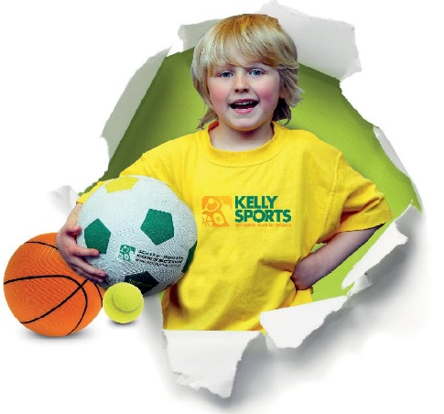

How To Enrol?
Please visit www.kellysports.com.au/events and search for your school.
Our new booking system requires upfront payments to secure your position. For more information, please call the head office.


"The Kelly Sports Programs offer our students opportunities for physical activities; including dance & multi-sports. Conveniently located on our school grounds, they are popular with students and their families. Staff are skilled in working with young people to love active participation.”


Amanda Hay, Principal – Newtown Primary School
CLASS INFORMATION

Activities include AFL, Soccer, Hockey, Basketball, plus we will incorporate our Kelly Sports Modified games children love

Come & join us every Tuesday straight after school.
No Programs Melbourne cup weekend (Tues 6th Nov)
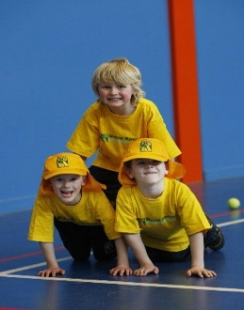
When: Tuesday
Starts: 9th October
Finishes: 11th December
Time: 3:40pm – 4:40pm
Year Levels: Prep – 4
Cost: $118.80 (Inc GST)

