
NEWTOWN
PRIMARY SCHOOL M 0423 280 873

E geelong@kellysports.com.au
CHEER, CHEER, CHEER!

Do you love to dance and work as a team?

It’s time to pick up those POM POMS and CHEER, CHEER, CHEER!
Our Kelly Sports CHEER DANCERS will learn an energetic dance routine with Pom Poms while developing TEAM SPIRIT and self confidence dancing the latest dance moves in Term 2.
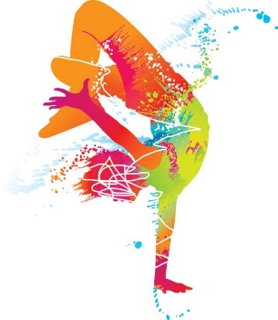
When: Mondays
Starts: 24th April
Finishes: 26th June
Time: 1:40pm – 2:30pm
Year Levels: Prep - 4

COST: 100 for 10 weeks (To enrol, please visit www.kellysports.com.au/events or call 0423 280 873)
VENUE: NEWTOWN PRIMARY SCHOOL

"The Kelly Sports Programs offer our students opportunities for physical activities; including dance & multi-sports. Conveniently located on our school grounds, they are popular with students and their families. Staff are skilled in working with young people to love active participation.”

Amanda Hay, Principal – Newtown Primary School

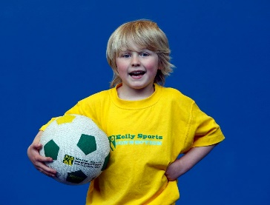
MULTI SPORTS MANIA

Come and experience all the fun our 11 week
Kelly Sports Multi Sport Mania program has to offer!

Our Kelly Sports program allows your child to play a range of dynamic & active sports over an 11-week program.
Activities include Footy, Soccer, Athletics, Basketball and much more!

Come & join us every Tuesday straight after school.

Join us each Wednesday straight after school!
When: Wednesdays
Starts: 19th April
Finishes: 28th June
Time: 3:30pm – 4:40pm
Year Levels: Prep - 4

COST: $100 – 11 WEEKS (To enrol, please visit www.kellysports.com.au/events or call 0428 055 677)
Students are offered one free trial session before signing up.

VENUE: NEWTOWN PRIMARY SCHOOL
