
ST JOHNS LUTHERAN
PRIMARY SCHOOL M 0428 055 677


E geelong@kellysports.com.au

MULTI SPORTS MANIA!

Come and experience all the fun our 9 week Kelly Sports
Multi Sports Mania program has to offer.
Conveniently located after school each Tuesday in a fun & positive environment, join us for
Footy, Soccer, Basketball, Cricket and much more!!

COST: $80 WEEKS for 9 weeks (To enrol, please visit www.kellysports.com.au/events or call 0428 055 677) Students are offered one free trial session before signing up
VENUE: ST JOHNS LUTHERAN PRIMARY SCHOOL

"The Kelly Sports Programs offer our students opportunities for physical activities; including dance & multi-sports. Conveniently located on our school grounds, they are popular with students and their families. Staff are skilled in working with young people to love active participation.”

Amanda Hay, Principal – Newtown Primary School

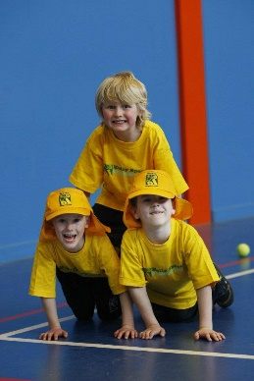
When: Thursdays
Starts: 4th May
Finishes: 29th June
Time: 3:30pm – 4:40pm
Year Levels: Prep - 4
CLASS INFORMATION
Our Kelly Sports program allows your child to play a range of dynamic & active sports over a 9 week program.
Activities include Footy, Soccer, Athletics, Basketball and much more!

Come & join us every Tuesday straight after school.

