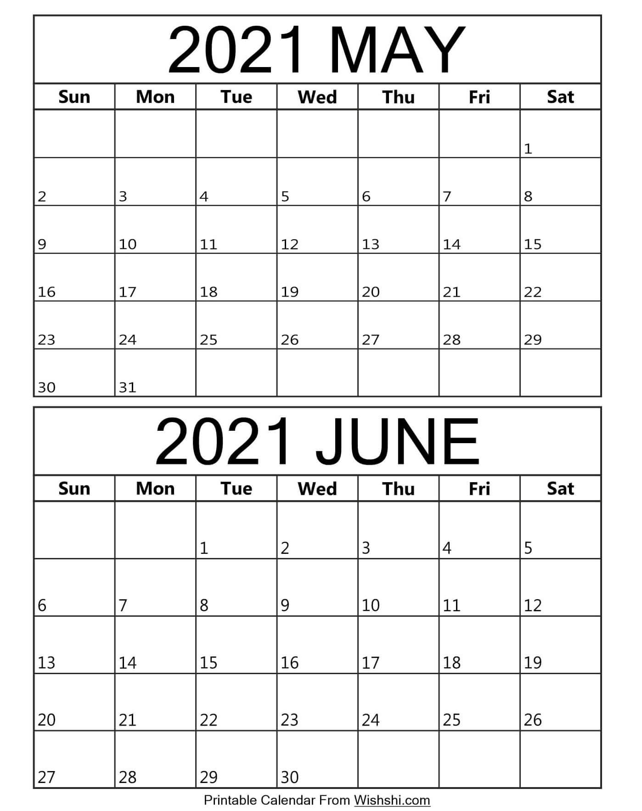

KELLY SPORTS DANCE TIMETABLE
Coach Jodie on annual leave
23/5 to 2/6
Coach Jodie on annual leave 23/5 to 2/6

Pt Lonsdale
Newtown Primary
Pt Lonsdale
Coach ELLIE
Coach ELLIE
St Roberts
P-2
St Roberts
3-6
Newtown Primary
SPORTS Newtown
St Roberts
3-6
St Roberts
3-6
Newtown Primary
Newtown Primary
St Roberts
3-6 PERFORMANCE
Newtown Primary
Newtown Primary Performance (afternoon)
St Roberts P-2 Performance (morning)
St Robert
P-2
St Roberts
P-2
St Roberts
P-2
3-6
St Roberts
P-2
3-6
PUBLIC HOLIDAY
Pt Lonsdale
PERFORMANCE
Pt Lonsdale
Pt Lonsdale
Newtown Primary
St Roberts P-2
St Roberts
3-6
St Roberts P-2
Pt Lonsdale
St Roberts
3-6
Pt Lonsdale
St Roberts
P-2
Pt Lonsdale
Newtown
Primary

