
ST ROBERTS NEWTOWN
PRIMARY SCHOOL M 0423 280 873

E geelong@kellysports.com.au
When: Tuesdays and Fridays
Starts: Tuesday 25th July Friday 28th July
Finishes: Tuesday 19th July Friday 22nd July
Time: 1:15pm – 2:15pm
Year Levels: Prep - 4
KELLY SPORTS DANCE
- ROCKSTARS

Do you love to sing and dance?!
Kelly Sports Dance ‘ROCKSTARS’ will rock your school with dance moves from the past to the future in Term 3. So be ready to bust out those dance moves and twist those hips to some old and new classic songs this term at Kelly Sports Dance!



COST: $90 – 9 WEEKS (To enrol, please visit www.kellysports.com.au/events or call 0423 280 873)
VENUE: ST ROBERTS NEWTOWN PRIMARY SCHOOL

"The Kelly Sports Programs offer our students opportunities for physical activities; including dance & multi-sports. Conveniently located on our school grounds, they are popular with students and their families. Staff are skilled in working with young people to love active participation.”

Amanda Hay, Principal – Newtown Primary School

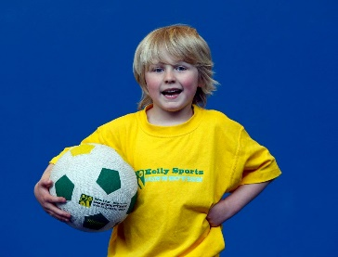
When: Fridays
Starts: 21st July
Finishes: 15th September
Time: 3:30pm – 4:40pm
Year Levels: Prep - 4
WACKY WINTER SPORTS!
Come and experience all the fun our 9 week Kelly Sports ‘Wacky Winter Sports’ program has to offer.
Conveniently located after school each Wednesday in a fun & positive environment, join us for
Football, Basketball, Soccer, Tennis and much more!!

COST: $80 – 9 WEEKS (To enrol, please visit www.kellysports.com.au/events or call 0428 055 677)
Students are offered one free trial session before signing up!
VENUE: ST ROBERTS NEWTOWN PRIMARY SCHOOL
