How to change your Electronic Sign in/out Pin

- Log in to your profile on our Kelly Sports Website: kellysports.com.au

- Click on my Details

- Click Change My Pin:

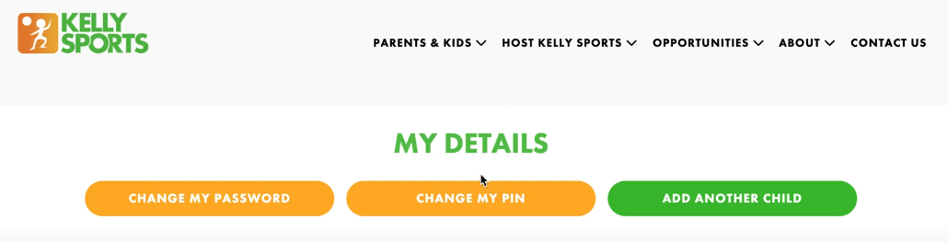

- Choose a 4 digit pin, confirm 4 digit pin and click save:
