
ST ROBERTS NEWTOWN
PRIMARY SCHOOL M 0423 280 873

E geelong@kellysports.com.au
KELLY SPORTS DANCE
HIP HOP!

Do you love to DANCE?
Our Kelly Sports 8 week Hip Hop classes are all inclusive, fun and interactive with a key focus on maximum participation!

This lunchtime program is not only a fantastic way for your child to get their groove on, but also great for their confidence and social skills! Don’t be afraid to bust a move!

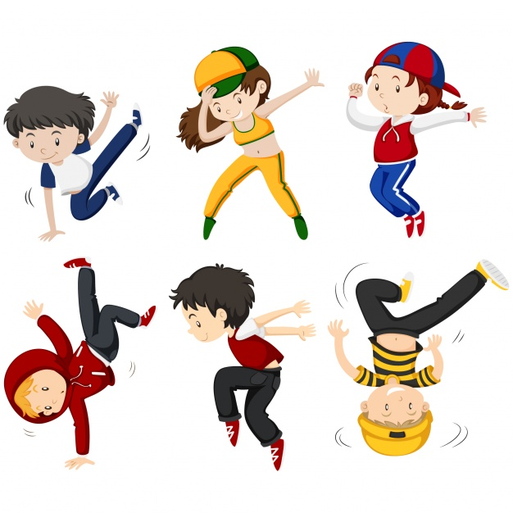
When: Tuesdays
Starts: 6th February 2018
Finishes: 27th March 2018
Time: 1:15pm – 2:15pm
Year Levels: Prep - 4

COST: $80 – 8 weeks (To enrol, please visit www.kellysports.com.au/events or call 0423 280 873)
VENUE: ST ROBERTS NEWTOWN PRIMARY SCHOOL

"The Kelly Sports Programs offer our students opportunities for physical activities; including dance & multi-sports. Conveniently located on our school grounds, they are popular with students and their families. Staff are skilled in working with young people to love active participation.”

Amanda Hay, Principal – Newtown Primary School

MULTI SPORT MAYHEM!
Come and experience all the fun our 7 week Kelly Sports ‘Multi Sport Mayhem’ Program has to offer.
Conveniently located after school each Friday in a fun and positive environment! Join us for
Basketball, Soccer, Cricket, Tennis and much more!

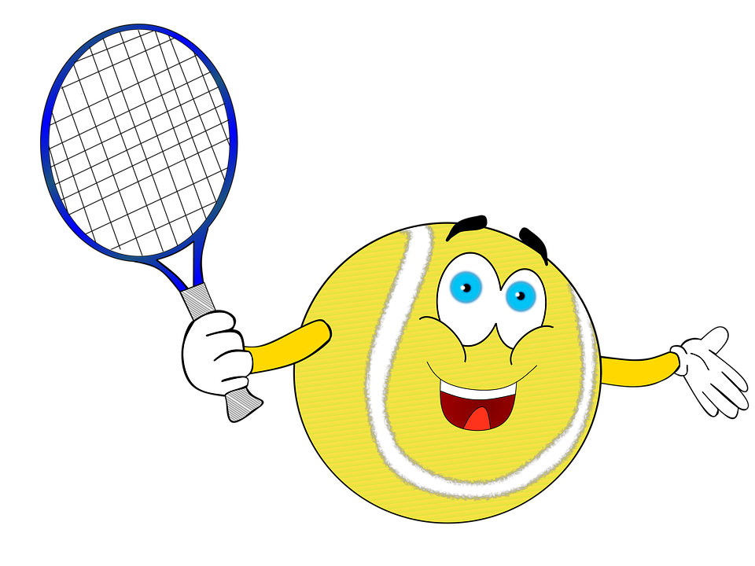
When: Fridays
Starts: 9th February
Finishes: 23rd March 2018
Time: 3:30pm – 4:40pm
Year Levels: Prep - 4

COST: $60 for 7 WEEKS (To enrol, please visit www.kellysports.com.au/events or call 0428 055 677)
Students are offered one free trial session before signing up!
VENUE: ST ROBERTS NEWTOWN PRIMARY SCHOOL
