
NEWTOWN
PRIMARY SCHOOL M 0423 280 873

E geelong@kellysports.com.au
KELLY SPORTS DANCE
HIP HOP!

Do you love to DANCE?
Our Kelly Sports 8 week Hip Hop classes are all inclusive, fun and interactive with a key focus on maximum participation!

This lunchtime program is not only a fantastic way for your child to get their groove on, but also great for their confidence and social skills! Don’t be afraid to bust a move!

When: Mondays
Starts: 5th February 2018
Finishes: 26th March 2018
Time: 1:40pm – 2:30pm
Year Levels: Prep - 4
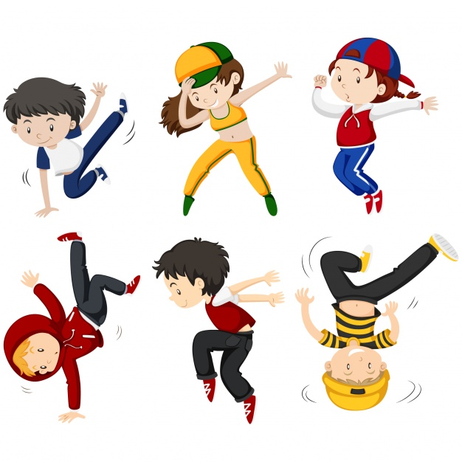

COST: $80 for 8 weeks (To enrol, please visit www.kellysports.com.au/events or call 0423 280 873)
VENUE: NEWTOWN PRIMARY SCHOOL

"The Kelly Sports Programs offer our students opportunities for physical activities; including dance & multi-sports. Conveniently located on our school grounds, they are popular with students and their families. Staff are skilled in working with young people to love active participation.”

Amanda Hay, Principal – Newtown Primary School
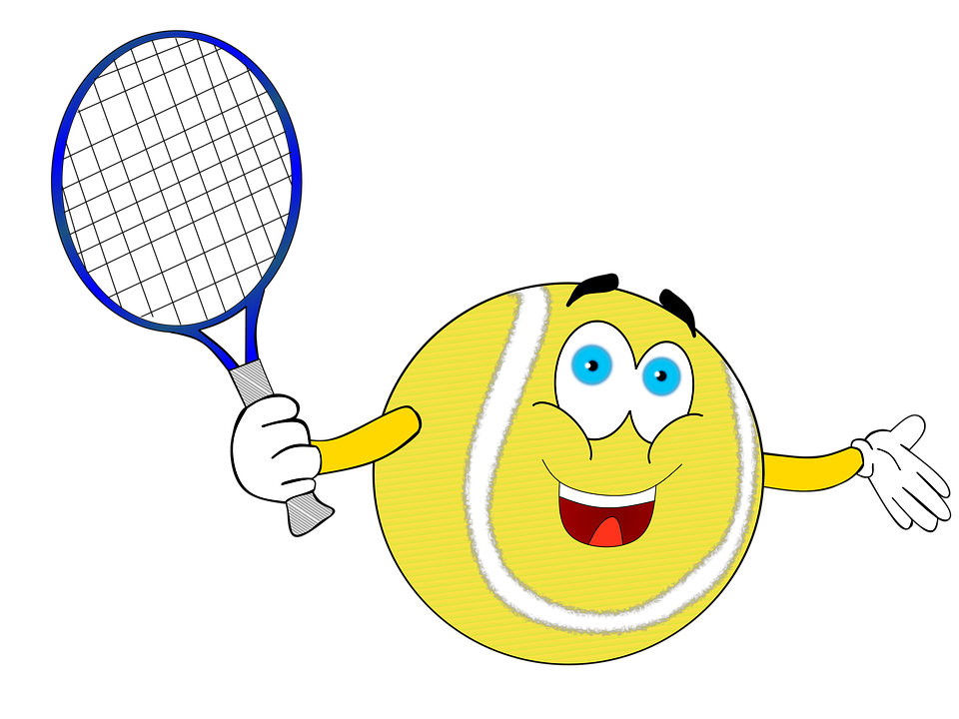

MULTI SPORT MAYHEM!
Come and experience all the fun our 8 week Kelly Sports ‘Multi Sport Mayhem’ Program has to offer.
Conveniently located after school each Wednesday in a fun and positive environment! Join us for
Basketball, Soccer, Cricket, Tennis and much more!

When: Wednesdays
Starts: 7th February 2018
Finishes: 28th March 2018
Time: 3:30pm – 4:40pm
Year Levels: Prep - 4

COST: $70 for 8 weeks (To enrol, please visit www.kellysports.com.au/events or call 0428 055 677)
Students are offered one free trial session before signing up!
VENUE: NEWTOWN PRIMARY SCHOOL
