
ST ROBERTS NEWTOWN
PRIMARY SCHOOL M 0423 280 873

E geelong@kellysports.com.au
CHEER, CHEER, CHEER!

Do you love to dance and work as a team?

It’s time to pick up those POM POMS and CHEER, CHEER, CHEER!
Our Kelly Sports CHEER DANCERS will learn an energetic dance routine with Pom Poms while developing TEAM SPIRIT and self confidence dancing the latest dance moves in Term 2.

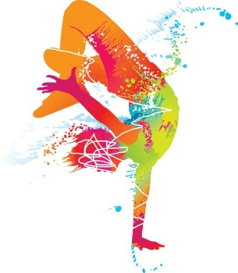
When: Tuesdays
Starts: 2nd May
Finishes: 27th June
Time: 1:15pm – 2:15pm
Year Levels: Prep - 4

COST: $90 – 9 WEEKS (To enrol, please visit www.kellysports.com.au/events or call 0423 280 873)
VENUE: ST ROBERTS NEWTOWN PRIMARY SCHOOL

"The Kelly Sports Programs offer our students opportunities for physical activities; including dance & multi-sports. Conveniently located on our school grounds, they are popular with students and their families. Staff are skilled in working with young people to love active participation.”

Amanda Hay, Principal – Newtown Primary School

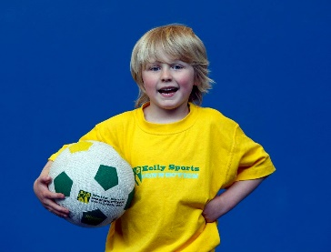
MULTI SPORTS MANIA
Come and experience all the fun our 9 week
Kelly Sports Multi Sport Mania program has to offer!

Our Kelly Sports program allows your child to play a range of dynamic & active sports over an 8-week program.
Activities include Footy, Soccer, Athletics, Basketball and much more!

When: Fridays
Starts: 28th April
Finishes: 23rd June
Time: 3:30pm – 4:40pm
Year Levels: Prep - 4

COST: $80 – 9 WEEKS (To enrol, please visit www.kellysports.com.au/events or call 0428 055 677)
Students are offered one free trial session before signing up.
VENUE: ST ROBERTS NEWTOWN PRIMARY SCHOOL
