
ASCOT VALE
PRIMARY SCHOOL M 0403 149 391

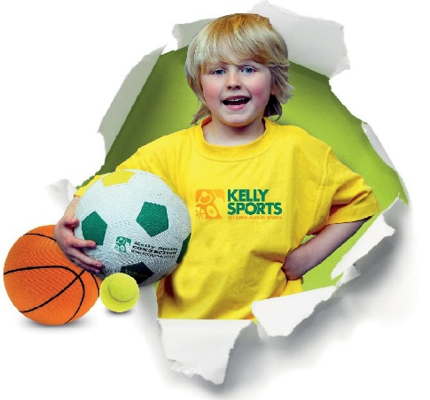
E mitch@kellysports.com.au
AWSOME AUTUUM SPORTS PROGRAM

Come and experience all the fun our 9 week Kelly Sports
Awsome Autuum Sports program has to offer.
Our Kelly Sports classes are all inclusive, fun & interactive with a key focus on maximum participation. Each week children will be introduced to new sports & activities in a positive environment. It’s a fantastic way to get your child active while having fun as well as building confidence and social skills!

Conveniently located after school each Wednesday in a fun & positive environment!

AFL, Basketball, Soccer & Hockey!!!

COST: $108 – 9 WEEKS (To enrol, please visit www.kellysports.com.au/events or call 0403 149 391)
VENUE: ASCOT VALE PRIMARY SCHOOL
MEETING PLACE: ON THE OVAL NEXT TO KELLY SPORTS BANNER
"The Kelly Sports Programs offer our students opportunities for physical activities; including dance & multi-sports. Conveniently located on our school grounds, they are popular with students and their families. Staff are skilled in working with young people to love active participation.”


Amanda Hay, Principal – Newtown Primary School


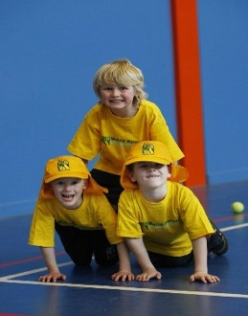
CLASS INFORMATION
Our Kelly Sports program allows your child to play a range of dynamic & active sports over a 9-week program.
Activities include BASKETBALL, AFL, SOCCER
& HOCKEY!

Come & join us every Wednesday straight after school.

When: Wednesdays
Starts: 2nd May
Finishes: 27th June
Time: 3:40pm – 4:40pm
Year Levels: Prep - 4

