
ESSENDON
PRIMARY SCHOOL P (03) 9384 2204
M 0403 149 391

E mitch@kellysports.com.au
SPRING MULTI SPORTS – After School
Come and experience all the fun in our 9 week Kelly Sports
Mighty Multi Sport program.
Our Kelly Sports classes are all inclusive, fun & interactive with a key focus on maximum participation. Each week children will be introduced to new sports & activities in a positive environment. It’s a fantastic way to get your child active while having fun as well as building confidence and social skills!
END OF YEAR CHEER – Lunch Time
IT’S THE END OF THE YEAR AND IT’S TIME TO CHEER!
Join us in Term 4 for our Cheerleading program for boys and girls. This program will combine both Hip Hop and Cheerleading to create a new and fresh routine. You will have a fantastic time learning the new moves in our high intensity, excitement-filled dance environment. Book early for this incredibly fun program!



How To Enrol?
Please visit www.kellysports.com.au/events and search for your school.
Our new booking system requires upfront payments to secure your position. For more information, please call the head office.


"The Kelly Sports Programs offer our students opportunities for physical activities; including dance & multi-sports. Conveniently located on our school grounds, they are popular with students and their families. Staff are skilled in working with young people to love active participation.”


Amanda Hay, Principal – Newtown Primary School
CLASS INFORMATION
Only 20 spots available for each program so sign up fast to secure your position
Mighty Multi Sports include AFL, Soccer, Tee ball, Basketball/Netball, plus we will incorporate our Kelly Sports Modified games children love.

Come & join us every Friday at lunch & straight after school.
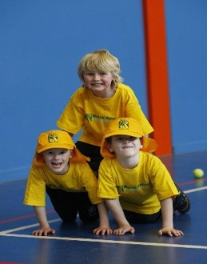
When: Fridays
Starts: 19th October
Finishes: 14th December
Sports: 3:40pm – 4:40pm
Dance: 1:30pm – 2:30pm
Year Levels: Prep – 4
Cost: $118.80 (Inc GST)

