

P.O. Box 71, Moonee Vale 3055
T (03) 9384 2204
F (03) 9384 2205
Book early to
Secure your
Place!
E sonya@kellysports.com.au


WILLIAMSTOWN NORTH PRIMARY
DANCE DANCE DANCE!
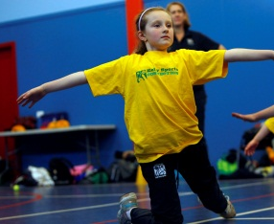
Shake, move and let the beat enter your feet with Kelly Sports. Our trained dance coaches can get your child’s hips swinging, heads bumping, feet rocking and bodies shaking to all of modern contemporary music’s classics. Sign up fast as places are limited and let our coaches beat ignite your child’s dancing feet.

WHEN: Wednesday
COMMENCING: 16/7/2014
CONCLUDING: 17/9/2014
TIME: 1:00pm – 2:00pm
YEAR LEVELS: P – 4



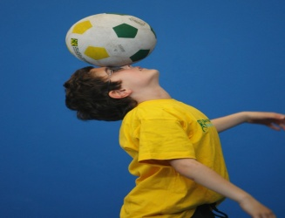
Don’t miss out on this fabulous Winter action, with our Wicked Winter Sports. This program allows your child to experience a fun, energetic and highly active multi-sport program over 10 lively weeks! These include: Dodgeball, Soccer, Footy and Turbo Touch . This program will not only provide an essential base for your child’s motor skills but help build awareness and co-ordination all in an enjoyable environment.

WHEN: Monday
COMMENCING: 14/7/2014
CONCLUDING: 15/9/2014
TIME: 3:40pm – 4 :40pm
YEAR LEVELS: P – 4
Wicked Winter Sports
COST: $100
It’s here online enrolments !
To enrol, please visit www.kellysports.com.au or
fill out the enrolment form & send with a cheque or credit card details to:
Kelly Sports PO BOX 71, Moonee Vale, VIC, 3055.
Payment options available!
Do not leave enrolment forms at the school office

VENUE: Williamstown North Primary School

It’s here online enrolments !
To enrol, please visit www.kellysports.com.au or
fill out the enrolment form & send with a cheque or credit card details to:
Kelly Sports PO BOX 71, Moonee Vale, VIC, 3055.
Payment options available!
Do not leave enrolment forms at the school office

ENROLMENT FORM
Dance Dance Dance! Wicked Winter Sports
School: Year Level:
Name: Room No:
Address: Post Code:
Phone: Mobile/Work:
Email: Medical Conditions:

At the completion of after school clinics, does your child? Go to after care Get collected
Parents’ consent: I hereby authorise Kelly Sports to act on my behalf should my child require medical attention, and release
Kelly Sports Essendon from any liability for injury incurred by my child at Kelly Sports programmes.
Parent/Caregiver name: Signature:

Amount Paid: $ ____________ Direct deposit: Bsb: 633 000 Acct: 142172618 Please quote child's surname as reference
Credit card payment: Visa Mastercard
Card Number: Expiry Date: /
To enrol, please visit http://www.kellysports.com.au
or fill out the below enrolment form & send with a cheque or credit
card details to:
PO BOX 71, Moonee Vale VIC 3055.
Do not leave enrolment forms at the school office.

ONLINE ENROLMENT
www.kellysports.com.au

It’s here online enrolments !
To enrol, please visit www.kellysports.com.au or
fill out the enrolment form & send with a cheque or credit card details to:
Kelly Sports PO BOX 71, Moonee Vale, VIC, 3055.
Payment options available!
Do not leave enrolment forms at the school office

It’s here online enrolments !
To enrol, please visit www.kellysports.com.au or
fill out the enrolment form & send with a cheque or credit card details to:
Kelly Sports PO BOX 71, Moonee Vale, VIC, 3055.
Payment options available!
Do not leave enrolment forms at the school office

It’s here online enrolments !
To enrol, please visit www.kellysports.com.au or
fill out the enrolment form & send with a cheque or credit card details to:
Kelly Sports PO BOX 71, Moonee Vale, VIC, 3055.
Payment options available!
Do not leave enrolment forms at the school office

