
P.O. Box 71, Moonee Vale 3055

T (03) 9384 2204
F (03) 9384 2205

E jeff@kellysports.com.au


ESSENDON PRIMARY SCHOOL

SUPER SUMMER SPORTS - CRICKET-SOCCER-BASKETBALL-ULTIMATE FRISBEE
Start the new school term by enrolling in this fantastic Kelly sports program. Join up with your friends and develop your skills in a fun, safe an exciting sporting environment. Our experienced coaches aim to develop and enhance the wide range of sporting skills of your child including kicking catching & throwing while also improving strength, flexibility, hand-eye co-ordination, Spatial awareness, co-operative and teamwork

WHEN: Friday
COMMENCING: 09/2/2018
CONCLUDING: 30/3/2018
TIME: 3.40pm – 4.40pm
YEAR LEVELS: P – 4

HIP HOP
Kelly sports Hip Hop is back in term 1!
Throughout the term students will have the opportunity to move, groove, spin and bop to the sound of some hip hop favourite tunes, alongside our very experience dance instructor. You will have a fantastic time learning the new moves in our high intensity excitement-filled environment.

WHEN: Friday
COMMENCING: 09/2/2018
CONCLUDING: 30/3/2018
TIME: 1.30pm – 2.30pm
YEAR LEVELS: P – 4

BASKETBALL
Speed! Precision! Athleticism! Fun! Enrol your child in the vibrant 8 week Basketball program we have on offer. With many engaging activities from passing, shooting & dribbling in this program, your child will be spoilt! This Basketball Program includes a chance for your child to not only be energetic, but build up their motor skills from the bottom up.
WHEN: Thursday
COMMENCING: 8/2/2018
CONCLUDING: 29/3/2018
TIME: 3.40pm – 4.40pm
YEAR LEVEL P – 4

COST: Thursday & Friday $96 for 8 weeks
It’s here online enrolments !
To enrol, please visit www.kellysports.com.au or
fill out the enrolment form & send with a cheque or credit card details to:
Kelly Sports PO BOX 71, Moonee Vale, VIC, 3055.
Payment options available!
Do not leave enrolment forms at the school office

VENUE: Essendon Primary School
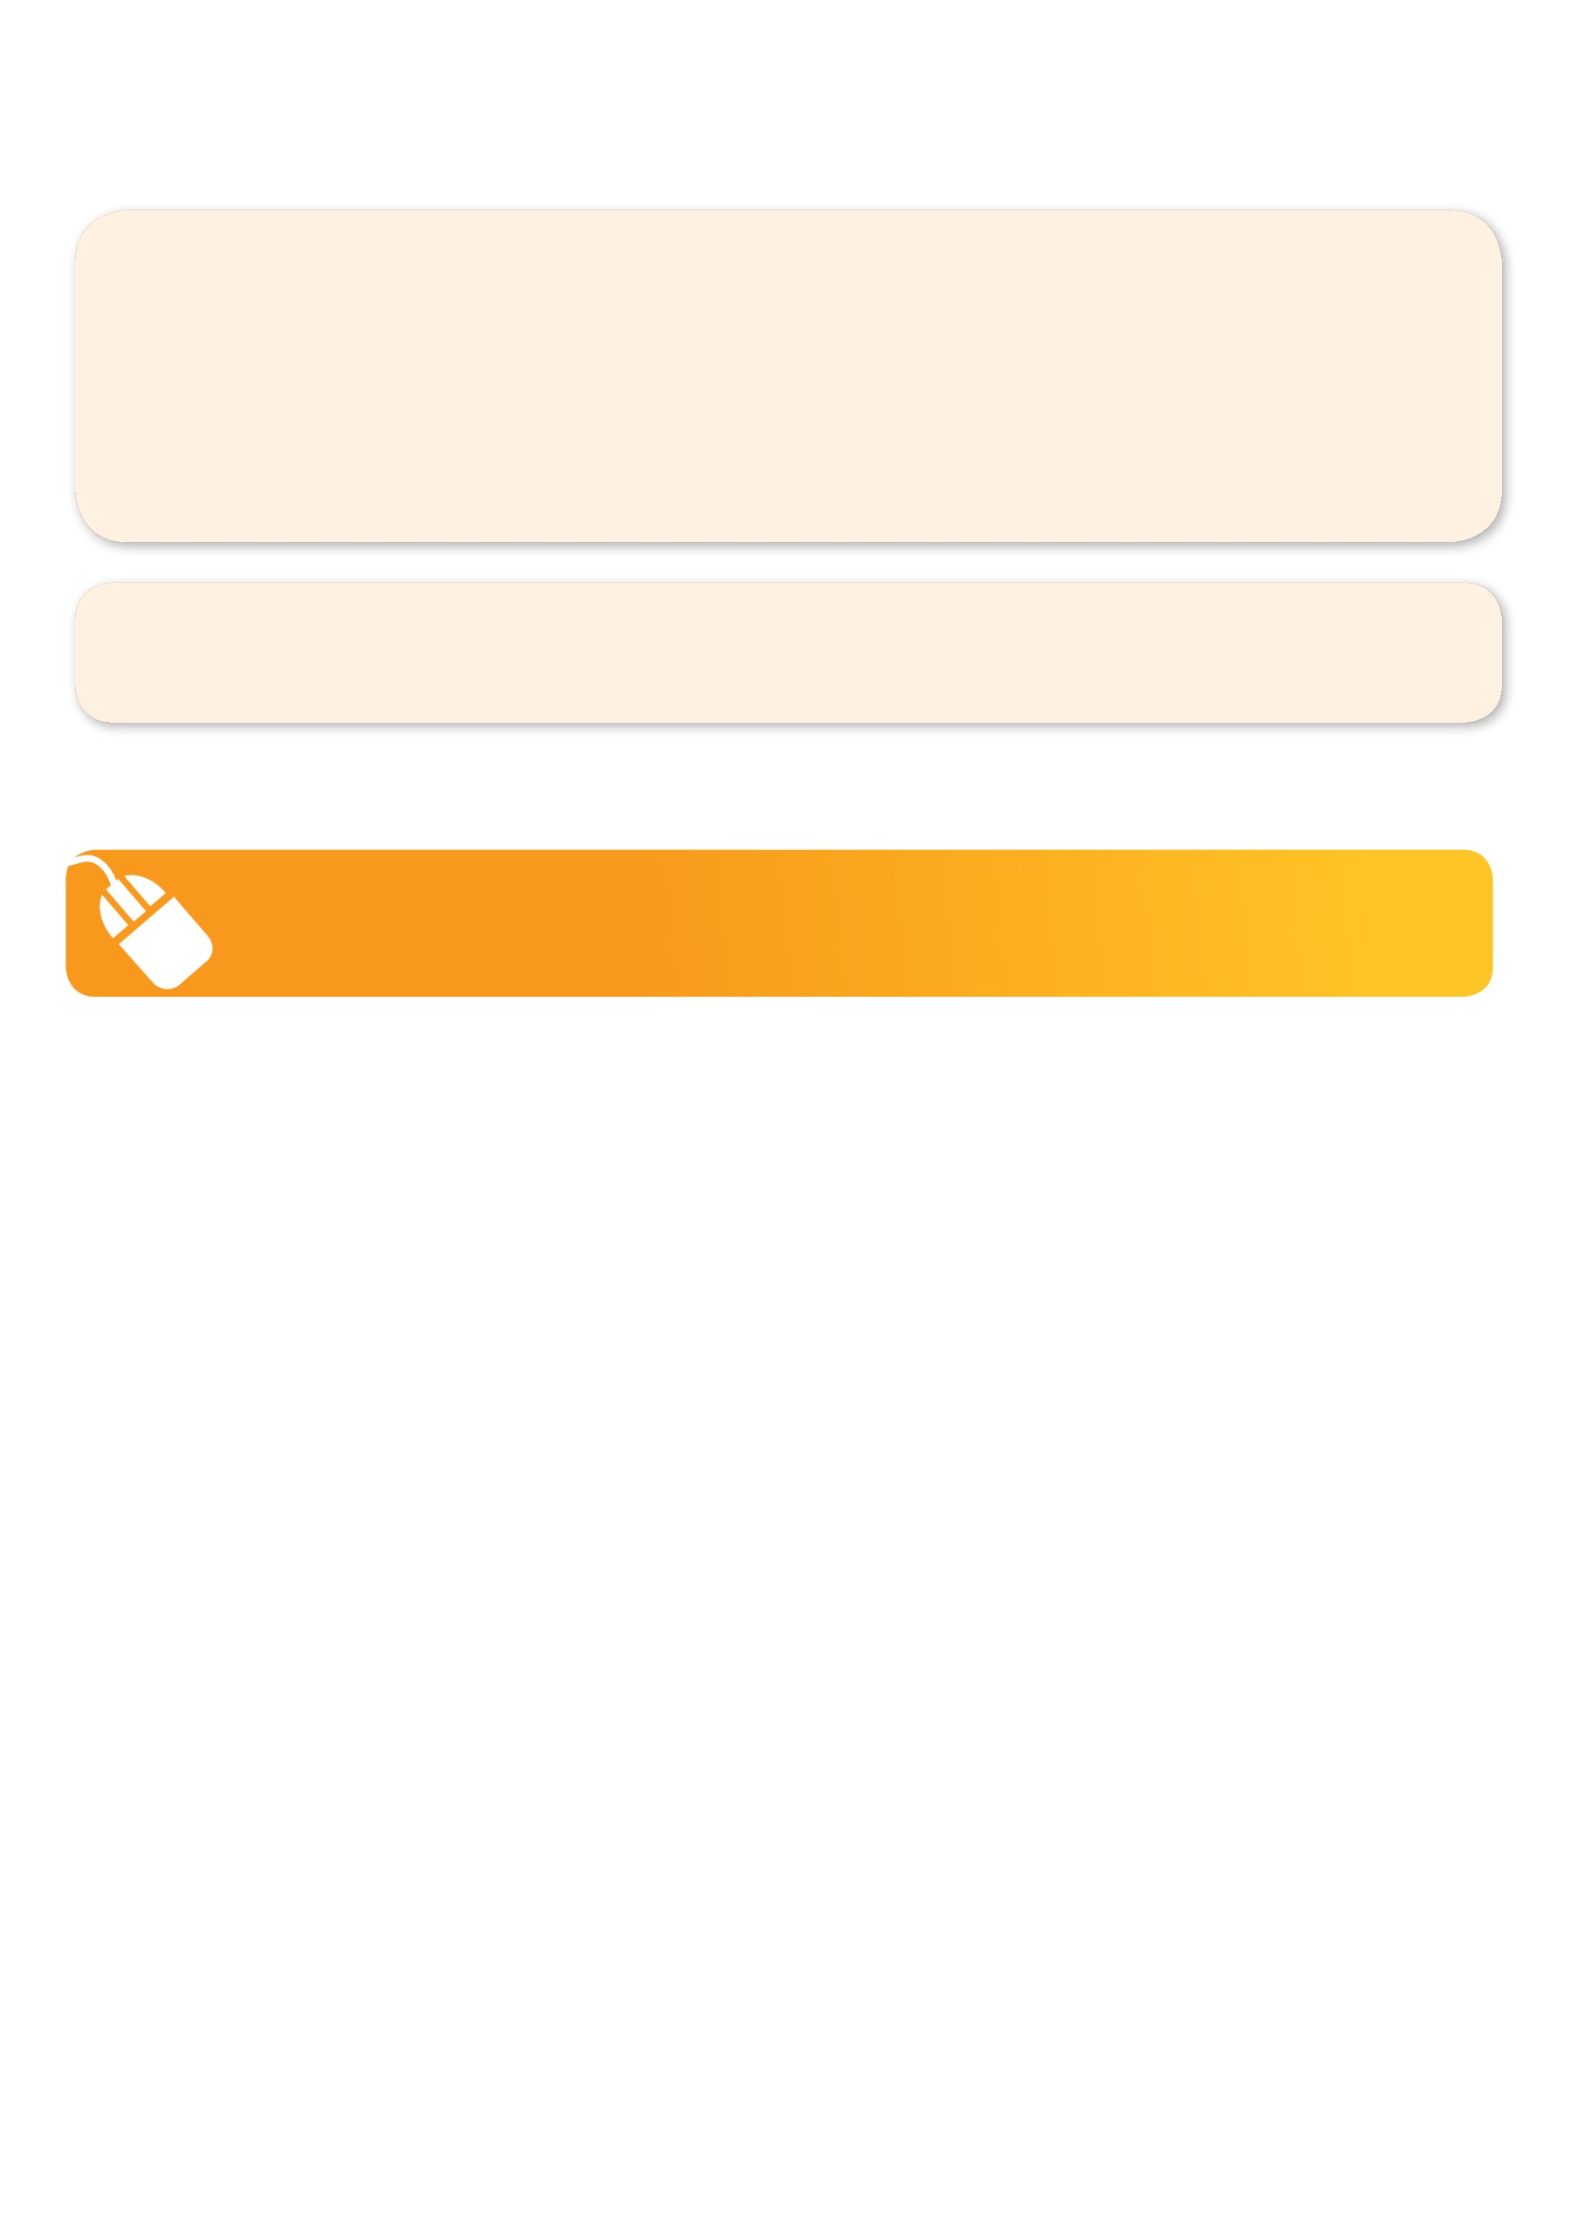
NEW IMPROVED ONLINE BOOKING SYSTEM!!!
SIMPLY GO TO WWW.KELLYSPORTS.COM.AU ENTER YOUR POST CODE AND ENROL FROM THERE. OR
FILL OUT THE BELOW ENROLMENT FORM & SEND WITH A CHEQUE OR CREDIT CARDS DETAILS TO:
PO BOX 71, MOONEE VALE, 3055
PAYMENT OPTIONS AVAILABLE!

It’s here online enrolments !
To enrol, please visit www.kellysports.com.au or
fill out the enrolment form & send with a cheque or credit card details to:
Kelly Sports PO BOX 71, Moonee Vale, VIC, 3055.
Payment options available!
Do not leave enrolment forms at the school office

ENROLMENT FORM
Super Summer Sport (After school) Hip Hop (Lunchtime) Basketball (Afterschool)
School: Year Level:
Name: Room No:
Address: Post Code:
Phone: Mobile/Work:
Email: Medical Conditions:

At the completion of after school clinics, does your child? Go to after care Get collected
Parents’ consent
I hereby authorise Kelly Sports to act on my behalf should my child require medical attention, and release Kelly Sports from
any liability for injury incurred by my child at Kelly Sports programmes.
I authorise the use by Kelly Sports of any photographs or video image of my child or legal charge for any reasonable purpose.
Parent/Caregiver name: Signature:
Amount Paid: $
It’s here online enrolments !
To enrol, please visit www.kellysports.com.au or
fill out the enrolment form & send with a cheque or credit card details to:
Kelly Sports PO BOX 71, Moonee Vale, VIC, 3055.
Payment options available!
Do not leave enrolment forms at the school office

It’s here online enrolments !
To enrol, please visit www.kellysports.com.au or
fill out the enrolment form & send with a cheque or credit card details to:
Kelly Sports PO BOX 71, Moonee Vale, VIC, 3055.
Payment options available!
Do not leave enrolment forms at the school office

It’s here online enrolments !
To enrol, please visit www.kellysports.com.au or
fill out the enrolment form & send with a cheque or credit card details to:
Kelly Sports PO BOX 71, Moonee Vale, VIC, 3055.
Payment options available!
Do not leave enrolment forms at the school office

