

P.O. Box 71, Moonee Vale 3055
Only $19.50 per week!
T (03) 9384 2204

E steve@kellysports.com.au

St KILDA PARK PRIMARY SCHOOL

SUPER SOCCER

Learn how to play like your heroes and have lots of fun learning all the skills in the game of SOCCER. The Kelly Sports team will teach you all the basic skills in a safe and challenging environment. If you already play soccer this is your chance to take your game to the next level!

WHEN: Monday
COMMENCING: 11/02/19
CONCLUDING: 1/04/19 (6 sessions)
TIME: 3.30pm – 5.00pm
YEAR LEVELS: P – 4
COST (GST inc): $117.00

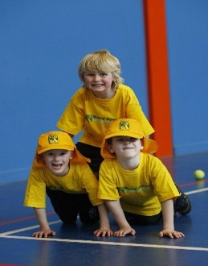


It’s here online enrolments !
To enrol, please visit www.kellysports.com.au or
fill out the enrolment form & send with a cheque or credit card details to:
Kelly Sports PO BOX 71, Moonee Vale, VIC, 3055.
Payment options available!
Do not leave enrolment forms at the school office

It’s here online enrolments !
To enrol, please visit www.kellysports.com.au or
fill out the enrolment form & send with a cheque or credit card details to:
Kelly Sports PO BOX 71, Moonee Vale, VIC, 3055.
Payment options available!
Do not leave enrolment forms at the school office

CLASS INFORMATION
Only 14 spots available for each session so sign up fast to secure your position
Activities will be fun, inclusive and exciting! Plus we will incorporate our Kelly Sports Modified games children love.

Come and join us in Term 1.

It’s here online enrolments !
To enrol, please visit www.kellysports.com.au or
fill out the enrolment form & send with a cheque or credit card details to:
Kelly Sports PO BOX 71, Moonee Vale, VIC, 3055.
Payment options available!
Do not leave enrolment forms at the school office

It’s here online enrolments !
To enrol, please visit www.kellysports.com.au or
fill out the enrolment form & send with a cheque or credit card details to:
Kelly Sports PO BOX 71, Moonee Vale, VIC, 3055.
Payment options available!
Do not leave enrolment forms at the school office

It’s here online enrolments !
To enrol, please visit www.kellysports.com.au or
fill out the enrolment form & send with a cheque or credit card details to:
Kelly Sports PO BOX 71, Moonee Vale, VIC, 3055.
Payment options available!
Do not leave enrolment forms at the school office

