
RIPPONLEA
PRIMARY SCHOOL P (03) 9384 2204

E mitch@kellysports.com.au
MIGHTY MULTI SPORTS – After School Monday
Come and experience all the fun in our 9-week Kelly Sports
Mighty Multi Sport program.
Our Kelly Sports classes are all inclusive, fun & interactive with a key focus on maximum participation. Each week children will be introduced to new sports & activities in a positive environment. It’s a fantastic way to get your child active while having fun as well as building confidence and social skills!



How To Enrol?
Please visit www.kellysports.com.au/events and search for your school.
Our new booking system requires upfront payments to secure your position. For more information, please call the head office.


"The Kelly Sports Programs offer our students opportunities for physical activities; including dance & multi-sports. Conveniently located on our school grounds, they are popular with students and their families. Staff are skilled in working with young people to love active participation.”


Amanda Hay, Principal – Newtown Primary School
CLASS INFORMATION
Limited spots for each program so sign up fast to secure your position
Mighty Multi Sports include AFL, Soccer, Basketball & Hockey plus we will incorporate our Kelly Sports Modified games children love.

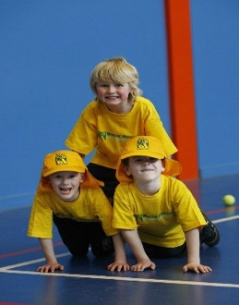
Sports – 9 week program
Starts: 29th of April
Finishes: 24th of June
Time: 3:30pm – 5:00pm
Cost : $175 (Inc GST)

