
P.O. Box 183, Black Rock 3193
T 9502 0611
M 0432 832 466
E pierre@kellysports.com.au
www.facebook.com/KellySportsBayside


BRIGHTON PS
SUPER SOCCER

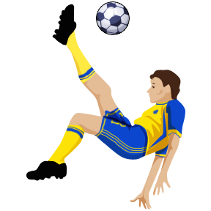
Play Soccer with your friends in the Kelly Sports Soccer Clinic. Now with 3 levels of coaching. Beginners (prep), Intermediate (1s) and Soccer Squad (y 2+) We recommend that children bring a snack for after school.

WHEN: Wednesday
COMMENCING: 16/7/14
CONCLUDING: 17/9/14
TIME: 3.30pm – 5.00pm
YEAR LEVELS: P – 4


WHEN: Wednesday
COMMENCING: 16/7/14
CONCLUDING: 17/9/14
TIME: 3.35pm – 4.35pm
YEAR LEVELS: P – 4

Have fun learning and playing Basketball with your friends. Great for all levels.

BASKETBALL

COST: Soccer $150 Basketball $115 (early bird rate $145 & $110 if paid before 11/7/14)
ONLINE ENROLMENT
www.kellysports.com.au/zone/brighton

enrol online go to www.kellysports.com.au and search for Brighton PS
VENUE: Brighton Primary School on oval and basketball court

TRY A CLASS AT NO COST. EMAIL pierre@kellysports.com.au
FOR A FREE TRIAL CLASS. GREAT FOR BOYS AND GIRLS

Why not have a Footy, Cricket, Soccer, Dance, Gymnastics, Hockey, Netball or any other Sporting Party. Have a coach from Kelly Sports come out and run your birthday party.


We supply all equipment, come to a venue of your choice, and the Birthday Boy or Girl chooses which games or sports they want to play. For more information call Pierre Sutcliffe at Kelly Sports Bayside on
9502 0611 or pierre@kellysports.com.au

