

Kelly Sports - Berwick & Pakenham
$45
per day!
P.O. Box 2055, Fountain Gate VIC 3805
T Darren Michelle 0402 224 116
F (03) 8692 6539
W www.kellysports.com.au
E darren@kellysports.com.au

AUTUMN HOLIDAY PROGRAM
OUR HOLIDAY PROGRAM IS NOW OFFERING EARLY CARE FROM 7:30AM ACTIVITIES START AT 9:00AM!
Sports orientated holiday program designed to emphasise fun, enjoyment, confidence and skills with maximum participation. Children require a packed lunch, drink bottle & hat. Craft table and restful activities also provided.
Suitable for both GIRLS and BOYS. Kelly Sports is a registered childcare provider
VENUE: Berwick Chase Primary School Hall, 72 Viewgrand Dr Berwick

WHEN: Term 1 Holidays
COMMENCING: Tuesday 3rd April
CONCLUDING: Friday 11th April
TIME: 7:30am – 4:30pm
YEAR LEVELS: All ages

Tue 3rd  7.30am-4.30pm | Basketball | Soccer  | Hockey  | Football | Touch Rugby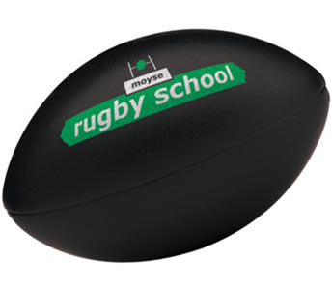
Wed 4th  7.30am-4.30pm | TENNIS  | GYM | Soccer | tBall | CRICKET
Thu 5th  7.30am-4.30pm | Soccer | Dance | Volleyball | Athletics | Basketball
Fri 6th  7.30am-4.30pm | Basketball | Netball | Football  | TENNIS | CRICKET
WEEK 1

Mon 9th  7.30am-4.30pm | Soccer | Basketball | Football | Hockey | TENNIS
Tue 10th  7.30am-4.30pm | Basketball | CRICKET | Hockey | Football | Dance
Wed 11th  7.30am-4.30pm | Volleyball | Touch Rugby | Soccer | Netball |   Tennis
Thu 12th  7.30am-4.30pm | Soccer | Athletics | Dance | Football | Basketball
Fri 13th  7.30am-4.30pm | tBall | CRICKET | Football | GYM | Soccer
WEEK 2
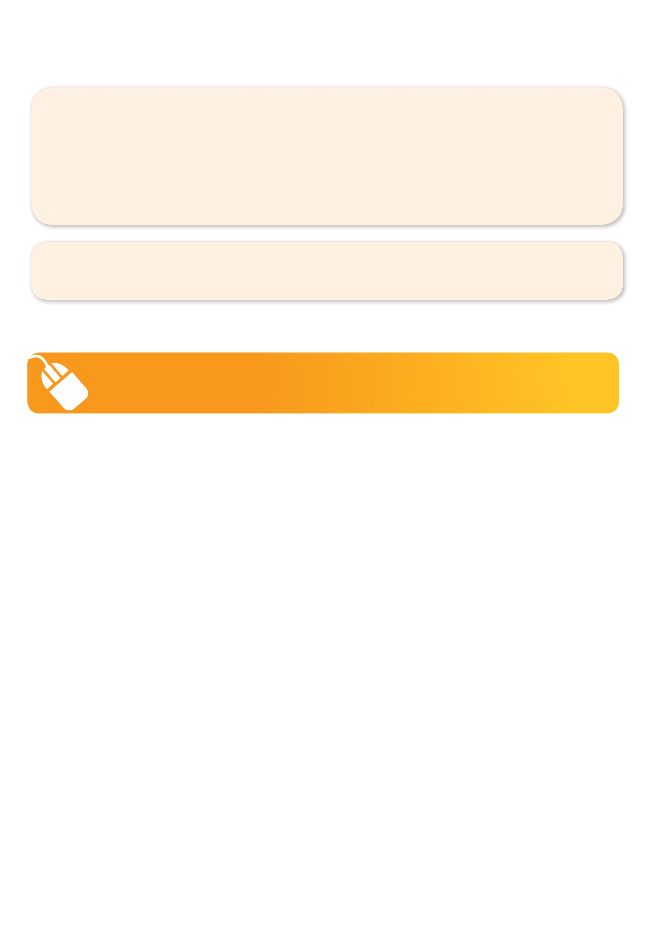
ONLINE ENROLMENT
www.kellysports.com.au/events

2013 Winner: Cardinia Business Awards 'Franchisee'
2015 Winner: City of Casey Home Based Business! 

ENROLMENT FORM
W1: Tue 3rd Wed 4th Thu 5th Fri 6th W2: Mon 9th Tue 10th Wed 11th Thu 12th Fri 13th
Name: DOB: Grade:
Address: Post Code:
Phone: Mobile/Work:
Email: Medical Conditions:
Parents’ consent I hereby authorise Kelly Sports to act on my behalf should my child require medical attention,
and release Kelly Sports Berwick from any liability for injury incurred by my child at Kelly Sports programmes.

Parent/Caregiver name: Signature: Amount Paid: $
Card: Exp/(online surcharge applies) Internet Transfer: Cash: Cheque:

ONLINE ENROLMENT
www.kellysports.com.au/events
search holiday program postcode 3806

