

Kelly Sports - Berwick & Pakenham
$40
per day
P.O. Box 2055, Fountain Gate VIC 3805
T Darren Michelle 0402 224 116
F (03) 8692 6539
W www.kellysports.com.au
E darren@kellysports.com.au


SUMMER HOLIDAY PROGRAM
Sports orientated holiday program designed to emphasise fun, enjoyment, confidence and skills with maximum participation. Children require a packed lunch, drink bottle & hat. Quiet, restful activities also provided.
Suitable for both GIRLS and BOYS Kelly Sports is a registered childcare provider.
VENUE: Berwick Chase Primary School GYM, 51 Bridgewater Blvd Berwick, enter via Viewgrand Dr.
WHEN: JANUARY 2015
COMMENCING: Monday 12th Jan
CONCLUDING: Friday 23rd Jan
TIME: 8:30am – 4:30pm
YEAR LEVELS: All ages

Mon 12th  8.30am-4.30pm | CRICKET | Soccer  | 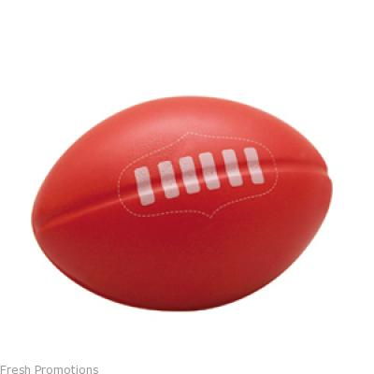Football | Netball | Dance 
Tue 13th  8.30am-4.30pm | Basketball | GYM | Hockey  | Football | Touch Rugby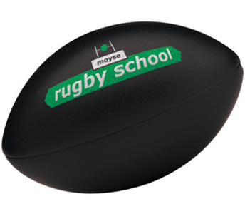
Wed 14th  8.30am-4.30pm | TENNIS  | Hip Hop | Soccer | Basketball | CRICKET
Thu 15th  8.30am-4.30pm | Soccer |   Tennis | Volleyball | Dance | Basketball
Fri 16th  8.30am-4.30pm | Basketball | tBall | Football | TENNIS | CRICKET
WEEK 2
WEEK 1

Mon 19th  8.30am-4.30pm | Soccer | Basketball | Hip Hop | Hockey | TENNIS
Tue 20th  8.30am-4.30pm | Basketball | CRICKET | Hockey | Football | Touch Rugby
Wed 21st  8.30am-4.30pm | Volleyball | Hip Hop | Soccer | Netball | Tennis
Thu 22nd  8.30am-4.30pm | Soccer | Athletics | GYM | Football | Basketball
Fri 23rd  8.30am-4.30pm | tBall | CRICKET | Football | GYM | Soccer
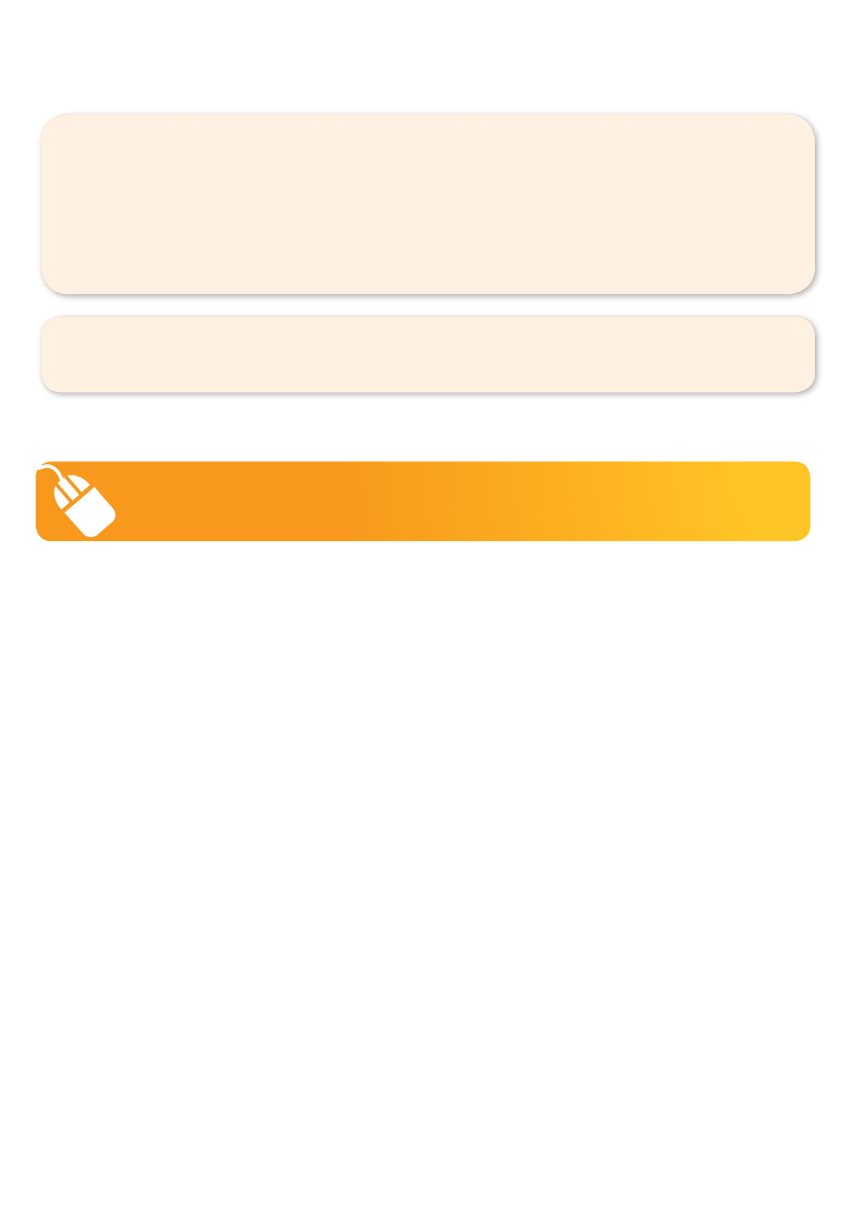

To enrol, please visit www.kellysports.com.au or fill out the below enrolment form & send with a cheque or credit card details to: PO BOX 2055, Fountain Gate VIC 3805, or scan to: darren@kellysports.com.au or fax to 03 8692 6539. Internet Direct credit available BSB: 083-214 Acct No: 15-985-2563 Acct Name: Kelly Sports Berwick
It’s here online enrolments !
To enrol, please visit www.kellysports.com.au or
fill out the enrolment form & send with a cheque or credit card details to:
Kelly Sports PO BOX 71, Moonee Vale, VIC, 3055.
Payment options available!
Do not leave enrolment forms at the school office

Winner: 2013 Cardinia Franchisee of the year!Winner: 2013 Casey Home Based Business Awards!
ENROLMENT FORM
W1: Mon 12th Tue 13th Wed 14th Thu 15th Fri 16th W2: Mon 19th Tue 20th Wed 21st Thu 22nd Fri 23rd
Name: DOB:
Address: Post Code:
Phone: Mobile/Work:
Email: Medical Conditions:
Parents’ consent I hereby authorise Kelly Sports to act on my behalf should my child require medical attention,
and release Kelly Sports Berwick from any liability for injury incurred by my child at Kelly Sports programmes.

Parent/Caregiver name: Signature: Amount Paid: $
Card: Exp/(online surcharge applies) Internet Transfer: Cash: Cheque:

ONLINE ENROLMENT
www.kellysports.com.au

It’s here online enrolments !
To enrol, please visit www.kellysports.com.au or
fill out the enrolment form & send with a cheque or credit card details to:
Kelly Sports PO BOX 71, Moonee Vale, VIC, 3055.
Payment options available!
Do not leave enrolment forms at the school office

It’s here online enrolments !
To enrol, please visit www.kellysports.com.au or
fill out the enrolment form & send with a cheque or credit card details to:
Kelly Sports PO BOX 71, Moonee Vale, VIC, 3055.
Payment options available!
Do not leave enrolment forms at the school office

It’s here online enrolments !
To enrol, please visit www.kellysports.com.au or
fill out the enrolment form & send with a cheque or credit card details to:
Kelly Sports PO BOX 71, Moonee Vale, VIC, 3055.
Payment options available!
Do not leave enrolment forms at the school office

