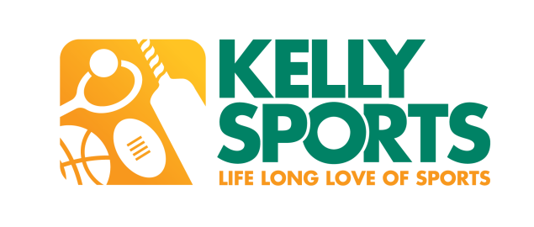

Kelly Sports Program at Spring Gully Primary School
Kelly Sports is looking forward to conducting clinics again at Spring Gully Primary School. We will be running a 10 week Mega Multi Sports program that includes 5 different sports including:
footy, netball, cricket, basketball & t-ball & a brand new 10 week Introduction to Gymnastics program that includes professionally designed lessons which focus on flexibility, coordination, balance & skillful gymnastics techniques using an array of apparatus including, hoops & ribbons.

Below are some details about our program and how your child could benefit.

For all enquiries about programs, please contact Brett Harris on 0438 198 031.

- Kelly Sports’ motto is Safe, Skill & Smile.

- Our programs cater for boys and girls from Prep – Grade 6.

- Kelly Sports provide highly trained coaches that cater to individuals’ needs.

- Children can be enrolled in After School Care, as coaches walk child to after school care once session has concluded to sign them in.

- Maximum ratio of 1 coach to 30 children (Gymnastics) & 1 coach to 14 children (Mega Multi Sports) to ensure maximum participation rate.

- Activities begin 10 minutes after the bell and go for 45 minutes (Gymnastics-lunchtime) 1 hour (Mega Multi Sports-afterschool).

- Children meet at a designated area where a roll is taken to ensure every child is accounted for before session is conducted.

- Clinics will be conducted on school grounds.

- $120 for 10 Fun and Challenging 1 hour sessions (Mega Multi Sports)

- $100 for 10 Exciting & Energetic 45 minute session (Gymnastics).

- Gymnastics (lunchtimes) starts Wednesdays 26th April & concludes 28th June 01:10 pm-01:55 pm.

- Mega Multi Sports (after school) starts Fridays 28th April & concludes 30th June 03:25 pm-04:25 pm

- To enrol, just check out www.kellysports.com.au, enter your school name, click GO and select Book Now from the program that you’d like to enrol your child in.

- **EARLY BIRD SPECIAL 10% OFF OFFER** If you enrol your child in any program before Sunday 23rd April you’ll receive 10% off!! (That’s 1 session FREE!!)
www.kellysports.com.au

