 | MON | TUES | WED  KELLY SPORTS BENDIGO  AUTUMN SCHOOL HOLIDAY PROGRAM  WEEK 1 | THURS | FRI
8:30 -9:00am | Public  Holiday | INTRO / FUN GAMES   | INTRO / FUN GAMES  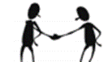 | INTRO / FUN GAMES | INTRO / FUN GAMES
9:00 - 10:00am | Public  Holiday | BASKETBALL   | SOCCER   | FOOTY   | T-BALL  
SNACK BREAK
10:30-11:30am | Public  Holiday | FOOTY | HOCKEY   | NETBALL  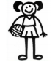 | SOCCER
11:30-12:00pm | Public  Holiday | T-BALL | GYMNASTICS   | DANCE   | HOCKEY
LUNCH
1:30-2:30pm | Public  Holiday | MINI OLYMPICS  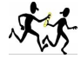 |   CRICKET |   VOLLEYBALL | BASKETBALL  
2:30-3:30pm | Public  Holiday | KIDS CHOICE   | CRAZY GAMES   | TENNIS  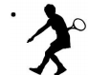 | TEAM BUILDING ACTIVITIES  
SNACK BREAK
4:00-5:00pm | Public  Holiday | PARACHUTE GAMES   | CIRCUS  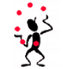 | KIDS CHOICE | PARACHUTE GAMES
HOME TIME



KELLY SPORTS BENDIGO
AUTUMN SCHOOL HOLIDAY PROGRAM
WEEK 2
 | MON | TUES | WED | THURS | FRI
8:30 - 9:00am |   INTRO / FUN GAMES | INTRO / FUN GAMES | INTRO / FUN GAMES | 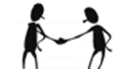  INTRO / FUN GAMES | INTRO / FUN GAMES
9:00 - 10:00am |   VOLLEYBALL | FOOTY | HOCKEY | FOOTY | BASKETBALL
SNACK BREAK
10:30-11:30am | CRICKET | NETBALL |   SCAVENGER HUNT | 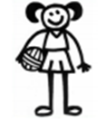  NETBALL | SOCCER
11:30-12:00pm | GYMNASTICS | DANCE | TENNIS | T-BALL | RIPPA RUGBY  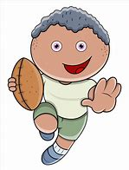
LUNCH
1:30-2:30pm | HOCKEY   | 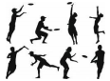  ULTIMATE FRISBEE | 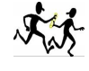  MINI OLYMPICS | VOLLEYBALL | HOCKEY  
2:30-3:30pm | KIDS CHOICE | TENNIS | SOCCER | CIRCUS | CRAZY GAMES
SNACK BREAK
4:00-5:00pm | CIRCUS | KIDS CHOICE | PARACHUTE GAMES   | KIDS CHOICE | PARACHUTE GAMES
HOME TIME

