BENDIGO SCHOOL HOLIDAY PROGRAM

BENDIGO WEEK 1

 | MON | TUES | WED | THUR | FRI
8.00 – 9.00am | INTRO / FUN GAMES   | INTRO / FUN GAMES | INTRO / FUN GAMES | INTRO / FUN GAMES | INTRO / FUN GAMES
9.00 – 10.00am | SOCCER  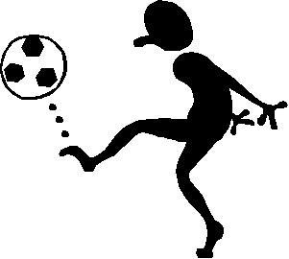 | BBALL   | FOOTY  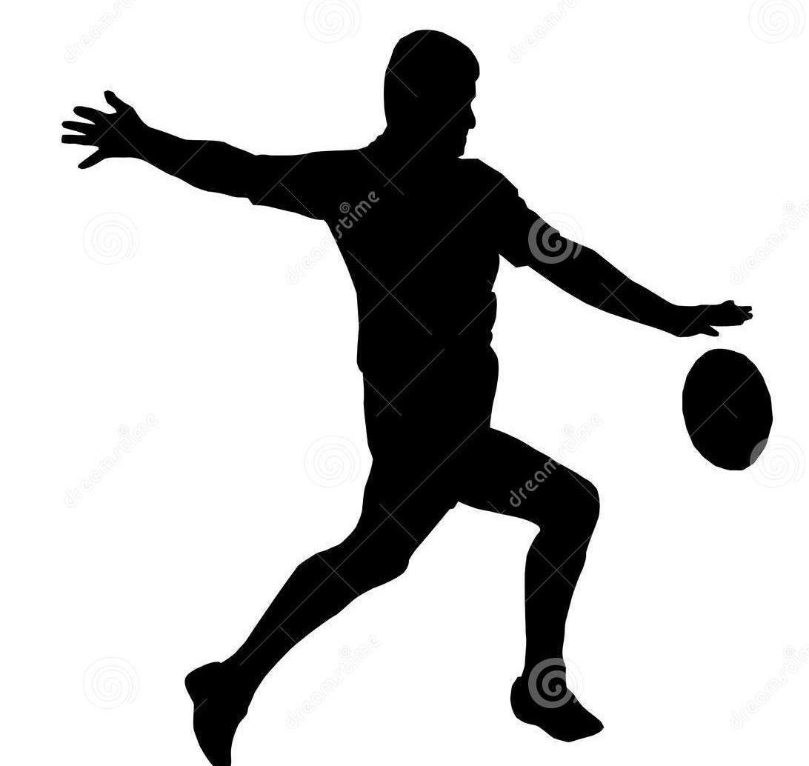 | HOCKEY   | T BALL  
 | SNACK BREAK
10 :30– 11:30am | CRICKET  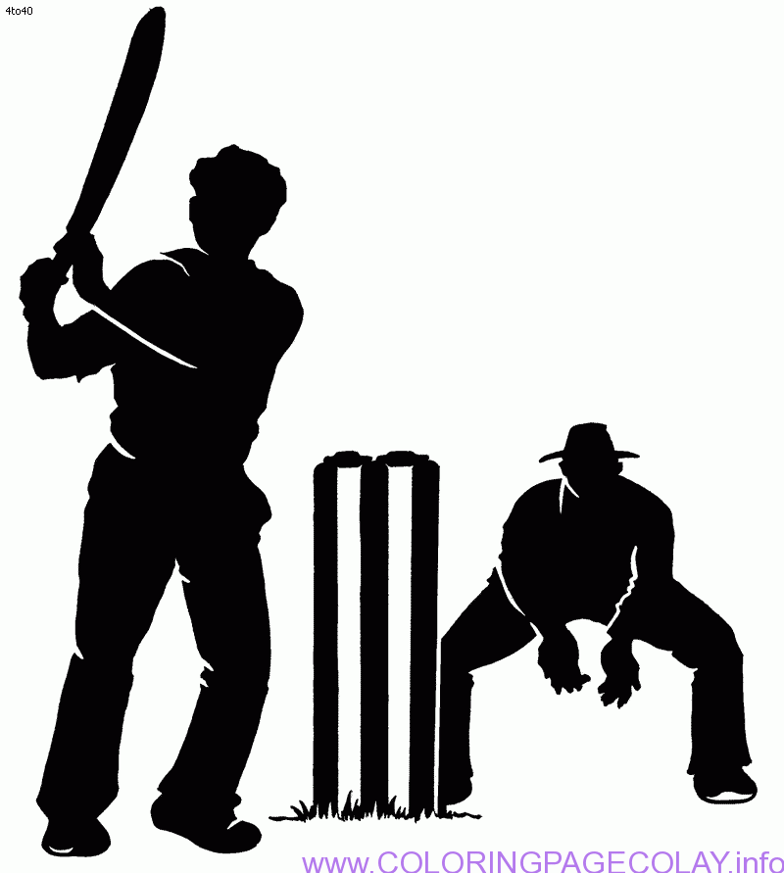 | DANCE   | RIPPA RUGBY   | SOCCER | CRICKET
11:30– 12:30pm | NETBALL  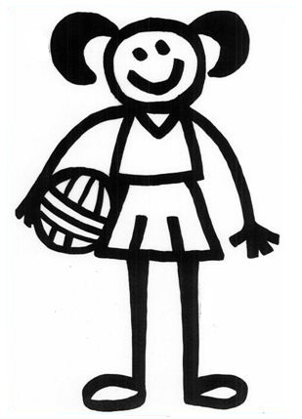 | HOCKEY | SOCCER | BBALL | RIPPA RUGBY
 | LUNCH
1:30 – 2:30pm | FOOTY | SCAVENGER HUNT   | T BALL | TRIVIA   | FOOTY
2:30– 3:30pm | KIDS CHOICE | ATHLETICS  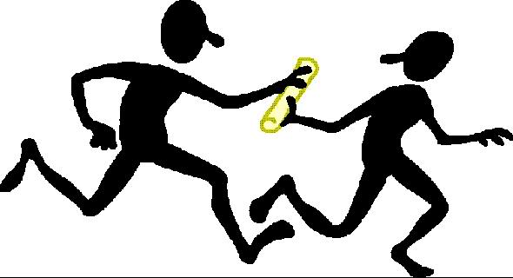 | CRAZY GAMES  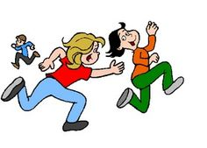 |   PARACHUTE GAMES | GYMNASTICS  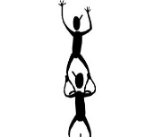
 | SNACK BREAK
4:00– 5:00pm | PARACHUTE GAMES | CIRCUS   | KIDS CHOICE | ULTIMATE FRISBEE  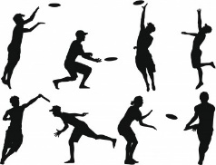 | KIDS CHOICE
 | HOME TIME
BENDIGO SCHOOL HOLIDAY PROGRAM BENDIGO WEEK 2

 | MON | TUES | WED | THUR | FRI
8 :00– 9.00am | INTRO / FUN GAMES | INTRO / FUN GAMES | INTRO / FUN GAMES | INTRO / FUN GAMES | INTRO / FUN GAMES
9.00 – 10.00am | SOCCER | NETBALL | FOOTY | HOCKEY | T BALL
 | SNACK BREAK
10 :30– 11:30am | CRICKET | HOCKEY | RIPPA RUGBY | SOCCER | CRICKET
11:30– 12:30pm | NETBALL | DANCE | SOCCER | BBALL | DANCE
 | LUNCH
1:30 – 2:30pm | FOOTY | AMAZING RACE   | T BALL | FOOTY | RIPPA RUGBY
2:30– 3:30pm | KIDS CHOICE | ATHLETICS | ULTIMATE FRISBEE | PARACHUTE GAMES | GYMNASTICS
 | SNACK BREAK
4:00– 5:00pm | PARACHUTE GAMES | CIRCUS | KIDS CHOICE | CRAZY GAMES | KIDS CHOICE
 | HOME TIME

