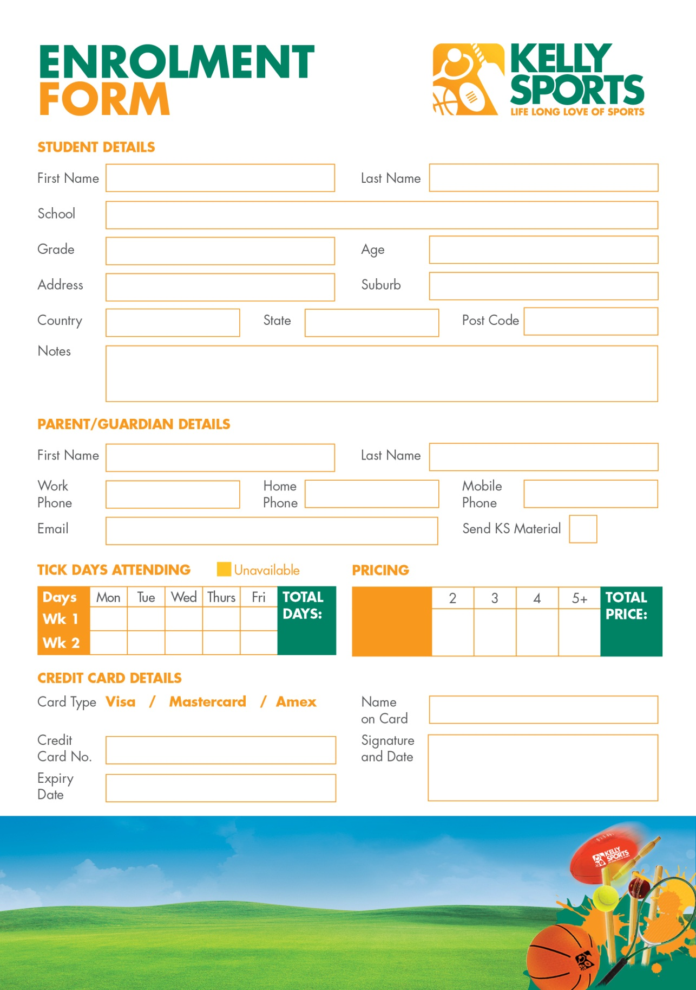
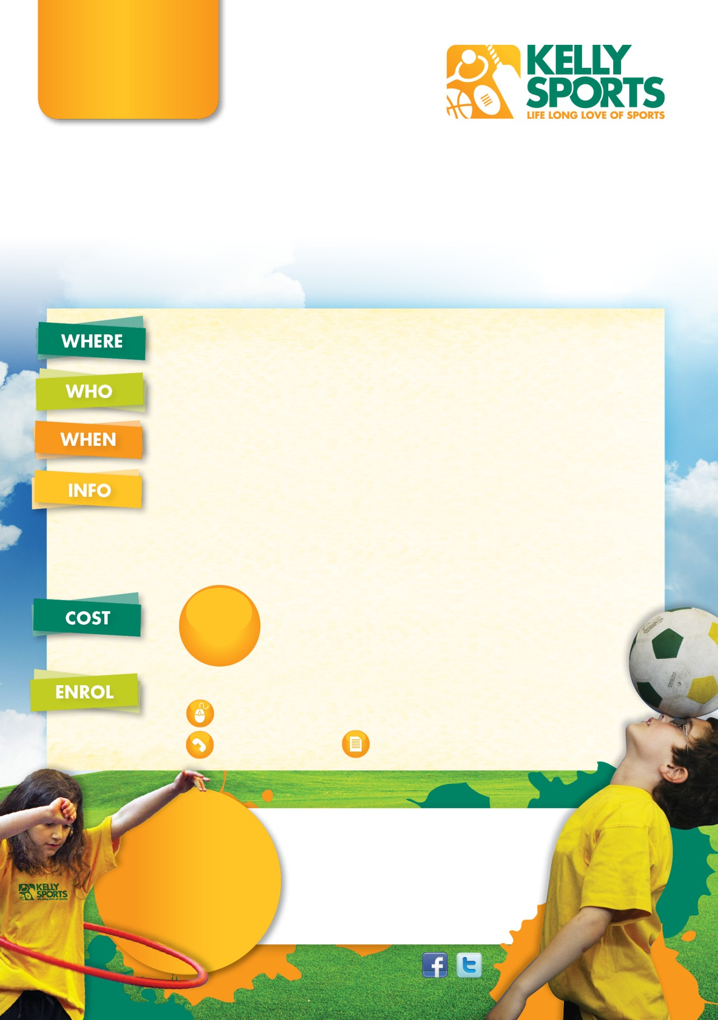
*School Programs *Kinder Programs *School Sports Days *Corporate Events
*Leadership/Teambuilding Events *Specialised Coaching

Would you like Kelly Sports at your school or kindergarten?
Enquire about our introductory FREE session today!

Price
per day: $40

$80

$120

$160

$175
($35 daily)

DID YOU KNOW KELLY SPORTS ALSO OFFERS?

___ days

$_______

Brett Harris
M 0438 198 031
E brett@kellysports.com.au
A 12 Metropolitan Drive,
Eaglehawk VIC 3556
HOLIDAY
PROGRAM

WINTER SCHOOL

HOLIDAY PROGRAM

Sports orientated holiday program designed for children
to emphasise fun, enjoyment and maximum participation.

QUARRY HILL COMMUNITY HALL
Hamlet St, Quarry Hill VIC 3550

Kinder-Grade 6 (Boys & Girls)

Monday 3rd to Friday 14th July 2017
8:00am-5:00pm(excluding Weekends & Public Holidays)

Kelly Sports are offering an exciting holiday sports program for kids this
Winter break!
• Friendly and experienced coaches teaching a variety of skills
throughout the whole day & providing an exciting and safe
environment.
•Sports & activities that all kids can enjoy such as: Basketball, Netball, Cricket, T-Ball, Soccer, Footy,
Dancing, Gymnastics, Circus activities, Parachute
& crazy games and much more.
**Children need to bring along a drink bottle,
lunch & plenty of healthy snacks.
***Enrol for 5 days or more for only $35 per day!

$40

FROM

PER DAY

THREE WAYS TO ENROL

Online: www.kellysports.com.au, click on events & enter postcode 3550

Call /text Brett

LOOK OUT!
SEE WHAT’S
COMING UP

KELLY SPORTS
DOES BIRTHDAY PARTIES!
For more info, go to
www.kellysports.com.au

*EARLY BIRD SPECIAL*
ENROL BEFORE FRIDAY 23rd JUNE & GET $5
OFF PER DAY!
*EARLY BIRD SPECIAL*
ENROL BEFORE FRIDAY 23rd JUNE & GET $5
OFF PER DAY!

Photo consent

Return the form (reverse side) in person or to the above address

