

FOLLOW US ONLINE

12 Metropolitan Drive, Eaglehawk VIC
M 0438 198 031

E brett@kellysports.com.au

W www.kellysports.com.au




SPRING GULLY PRIMARY SCHOOL
MEGA MULTI-SPORTS
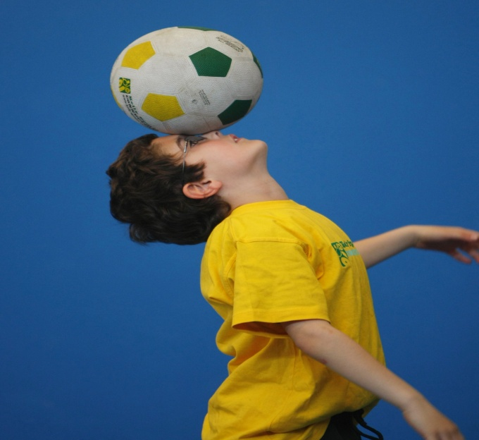
SOCCER - HOCKEY - AFL
This program is a fantastic way to challenge and improve your child’s motor and coordination skills. Our experienced coaches aim to develop and enhance the wide range of sporting skills of your child, including catching, kicking & throwing. While also improving strength, flexibility, hand-eye co-ordination, spatial awareness, co-operative skills and teamwork, all within a FUN and very SAFE environment.

WHEN: Friday
COMMENCING: 03/03/17
CONCLUDING: 31/03/17
DURATION: 5 weeks
TIME: 3:25pm – 4:25pm
YEAR LEVELS: P – 4
COST: $60


GYMNASTICS FUN

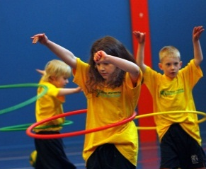
WHEN: Thursday
COMMENCING: 02/03/17
CONCLUDING: 31/03/17
DURATION: 5 weeks
TIME: 1:10pm - 1:55pm
YEAR LEVELS: P – 6
COST: $50

This fun fast paced, highly active and non-stop program is an introduction for your child to the world of gymnastics. Colourful ribbons, entertaining hula hoops, incredible rhythmical routines and group dynamics. Allow your child to build their gymnastics skills and their thirst for exciting energetic activities.

GET IN QUICK FOR TERM 1 AS PLACES ARE FILLING FAST!!
It’s here online enrolments!
To enrol, please visit www.kellysports.com.au or
fill out the enrolment form & send with a cheque or credit card details to:
Kelly Sports PO BOX 71, Moonee Vale, VIC, 3055.
Payment options available!
Do not leave enrolment forms at the school office


NEW & IMPROVED ONLINE BOOKING SYSTEM!!
SIMPLY GO TO WWW.KELLYSPORTS.COM.AU ENTER YOUR POSTCODE AND ENROL FROM THERE OR
FILL OUT THE BELOW ENROLMENT FORM & SEND WITH A CHEQUE OR CREDIT CARD DETAILS TO:
12 METROPOLITAN DRIVE, EAGLEHAWK VIC 3556
PAYMENT OPTIONS AVALIABLE!

It’s here online enrolments!
To enrol, please visit www.kellysports.com.au or
fill out the enrolment form & send with a cheque or credit card details to:
Kelly Sports PO BOX 71, Moonee Vale, VIC, 3055.
Payment options available!
Do not leave enrolment forms at the school office

ENROLMENT FORM
Mega Multi Sports Gymnastics Fun
School: Year Level:
Name: Room No:
Address: Post Code:
Phone: Mobile/Work:
Email: Medical Conditions:

At the completion of after school clinics, does your child? Go to after care Get collected
Parents’ consent: I hereby authorise Kelly Sports to act on my behalf should my child require medical attention, and release
Kelly Sports Bendigo from any liability for injury incurred by my child at Kelly Sports programs.
Parent/Caregiver name: Signature:
Amount Paid: $ Credit card payment: Visa Master card
Card Number: Expiry Date: /CVV:
THINGS TO KNOW
Kelly Sports is a Registered Child Care provider
Don’t leave forms at the School Office
Spaces are limited so please make sure you enrol online or return form to Kelly Sports

It’s here online enrolments!
To enrol, please visit www.kellysports.com.au or
fill out the enrolment form & send with a cheque or credit card details to:
Kelly Sports PO BOX 71, Moonee Vale, VIC, 3055.
Payment options available!
Do not leave enrolment forms at the school office

It’s here online enrolments!
To enrol, please visit www.kellysports.com.au or
fill out the enrolment form & send with a cheque or credit card details to:
Kelly Sports PO BOX 71, Moonee Vale, VIC, 3055.
Payment options available!
Do not leave enrolment forms at the school office

It’s here online enrolments!
To enrol, please visit www.kellysports.com.au or
fill out the enrolment form & send with a cheque or credit card details to:
Kelly Sports PO BOX 71, Moonee Vale, VIC, 3055.
Payment options available!
Do not leave enrolment forms at the school office

