

FOLLOW US ONLINE

12 Metropolitan Drive, Eaglehawk VIC
M 0438 198 031

E brett@kellysports.com.au

W www.kellysports.com.au




WHITE HILLS PRIMARY SCHOOL
WHEN: Wednesday
WHERE: White Hills PS Undercover basketball courts
COMMENCING: 26/07/17
CONCLUDING: 13/09/17
DURATION: 8 weeks
TIME: 3:40pm – 4:40pm
YEAR LEVELS: P – 4
COST: $96

MEGA MULTI-SPORTS
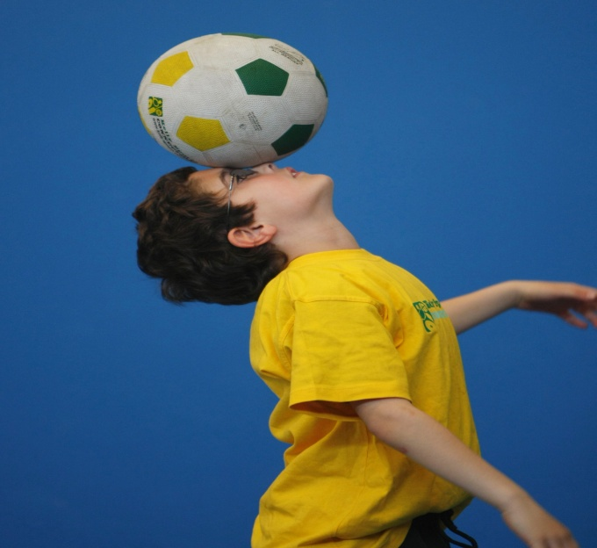
FOOTY – VOLLEYBALL – TOUCH RUGBY – CRAZY GAMES
This program is a fantastic way to challenge and improve your child’s motor and coordination skills. Our experienced coaches aim to develop and enhance the wide range of sporting skills of your child, including catching, kicking & throwing. While also improving strength, flexibility, hand-eye co-ordination, spatial awareness, co-operative skills and teamwork, all within a FUN and very SAFE environment.


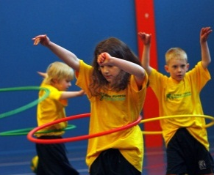
WHEN: Thursday
WHERE: White Hills PS music room
COMMENCING: 27/07/17
CONCLUDING: 14/09/17
DURATION: 8 weeks
TIME: 1:40pm - 2:25pm
YEAR LEVELS: P – 6
COST: $80

CIRCUS & GYMNASTICS

Twist, flip & leap into an exciting Circus & Gymnastics program with Kelly Sports! This fast-paced, highly active program is a fantastic introduction to the wonderful world of circus & gymnastics tricks! Colourful ribbons, hula hoops, spinning plates, juggling scarves, diablos, sits, supports, jumps & landings will be sure to improve balance, co-ordination, muscle strength & group dynamics all in a FUN, EXCITING & SAFE environment!

GET IN QUICK FOR TERM 3 AS PLACES ARE FILLING FAST!!
It’s here online enrolments !
To enrol, please visit www.kellysports.com.au or
fill out the enrolment form & send with a cheque or credit card details to:
Kelly Sports PO BOX 71, Moonee Vale, VIC, 3055.
Payment options available!
Do not leave enrolment forms at the school office

**EARLY BIRD SPECIAL OFFER** If you enrol your child in any program before
Sunday 16th July you’ll receive 1 session FREE!!


NEW & IMPROVED ONLINE BOOKING SYSTEM!!
SIMPLY GO TO WWW.KELLYSPORTS.COM.AU ENTER YOUR POSTCODE AND ENROL FROM THERE OR
FILL OUT THE BELOW ENROLMENT FORM & SEND WITH A CHEQUE OR CREDIT CARD DETAILS TO:
12 METROPOLITAN DRIVE, EAGLEHAWK VIC 3556
PAYMENT OPTIONS AVALIABLE!

It’s here online enrolments !
To enrol, please visit www.kellysports.com.au or
fill out the enrolment form & send with a cheque or credit card details to:
Kelly Sports PO BOX 71, Moonee Vale, VIC, 3055.
Payment options available!
Do not leave enrolment forms at the school office

ENROLMENT FORM
Mega Multi Sports Circus & Gymnastics
School: Year Level: DOB:___________
Name: Room No:
Address: Post Code:
Phone: Mobile/Work:
Email: Medical Conditions:

Emergency Contact:___________________________________ Phone:____________________ Relationship:________________________________

At the completion of after school clinics, does your child? Go to after care Get collected Photo consent
Parents’ consent: I hereby authorise Kelly Sports to act on my behalf should my child require medical attention, and release
Kelly Sports Bendigo from any liability for injury incurred by my child at Kelly Sports programs.
Parent/Caregiver name: Signature:
Amount Paid: $ Credit card payment: Visa Master card
Card Number: Expiry Date: /CVV:
THINGS TO KNOW
Kelly Sports is a Registered Child Care provider
Don’t leave forms at the School Office
Spaces are limited so please make sure you enrol online or return form to Kelly Sports

It’s here online enrolments !
To enrol, please visit www.kellysports.com.au or
fill out the enrolment form & send with a cheque or credit card details to:
Kelly Sports PO BOX 71, Moonee Vale, VIC, 3055.
Payment options available!
Do not leave enrolment forms at the school office

It’s here online enrolments !
To enrol, please visit www.kellysports.com.au or
fill out the enrolment form & send with a cheque or credit card details to:
Kelly Sports PO BOX 71, Moonee Vale, VIC, 3055.
Payment options available!
Do not leave enrolment forms at the school office

It’s here online enrolments !
To enrol, please visit www.kellysports.com.au or
fill out the enrolment form & send with a cheque or credit card details to:
Kelly Sports PO BOX 71, Moonee Vale, VIC, 3055.
Payment options available!
Do not leave enrolment forms at the school office

