

P.O. Box 71, Moonee Vale 3055
FOLLOW US ONLINE!

T (03) 9384 2204
F (03) 9384 2205

E mitch@kellysports.com.au






GREENVALE PRIMARY SCHOOL
AWESOME AUTUMN SPORTS
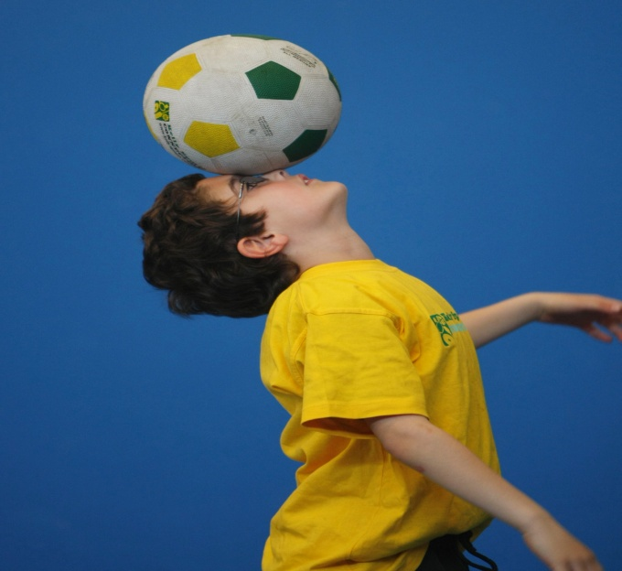
WHEN: Thursday
COMMENCING: 26/04/18
CONCLUDING: 28/06/18
TIME: 3.40pm – 4.40pm
YEAR LEVELS: P – 4
COST: $120

AFL - SOCCER-BASKETBALL-HOCKEY – TEAM GAMES
Start the new school term by enrolling in this fantastic Kelly sports program. Join up with your friends and develop your skills in a fun, safe an exciting sporting environment. Our experienced coaches aim to develop and enhance the wide range of sporting skills of your child including kicking catching & throwing while also improving strength, flexibility, hand-eye co-ordination, Spatial awareness, co-operative and teamwork



WHEN: Thursday
COMMENCING: 26/04/18
CONCLUDING: 28/06/18
TIME: 3.40pm – 4.40pm
YEAR LEVELS: P – 4
COST: $120

CIRCUS SKILLS

WHO LIKES TO ACT LIKE A CLOWN! Learn to juggle, spin plates, use devil sticks and have lots of fun with all our exciting circus skills program. This program also includes skipping drills, hula hoops and encourages participants to use their creative minds to put together their own circus performance.

GET IN QUICK FOR TERM 2 AS PLACES FILLING FAST
It’s here online enrolments !
To enrol, please visit www.kellysports.com.au or
fill out the enrolment form & send with a cheque or credit card details to:
Kelly Sports PO BOX 71, Moonee Vale, VIC, 3055.
Payment options available!
Do not leave enrolment forms at the school office


$120 FOR 10 WEEK PORGRAM
NEW IMPROVED ONLINE BOOKING SYSTEM!!!
SIMPLY GO TO WWW.KELLYSPORTS.COM.AU ENTER YOUR POST CODE AND ENROL FROM THERE. OR
FILL OUT THE BELOW ENROLMENT FORM & SEND WITH A CHEQUE OR CREDIT CARDS DETAILS TO:
PO BOX 71, MOONEE VALE, 3055
PAYMENT OPTIONS AVALIABLE!

It’s here online enrolments !
To enrol, please visit www.kellysports.com.au or
fill out the enrolment form & send with a cheque or credit card details to:
Kelly Sports PO BOX 71, Moonee Vale, VIC, 3055.
Payment options available!
Do not leave enrolment forms at the school office

ENROLMENT FORM
Awesome Autumn Sports Circus Skills
School: Year Level:
Name: Room No:
Address: Post Code:
Phone: Mobile/Work:
Email: Medical Conditions:

At the completion of after school clinics, does your child? Go to after care Get collected
Parents’ consent: I hereby authorise Kelly Sports to act on my behalf should my child require medical attention, and release
Kelly Sports Nth West from any liability for injury incurred by my child at Kelly Sports programs.
Parent/Caregiver name: Signature:
Amount Paid: $ Credit card payment: Visa Master card
Card Number: Expiry Date: /CVV:
THINGS TO KNOW
Kelly Sports is a Registered Child Care provider
Don’t leave forms at the School Office
Spaces are limited so please make sure you enrol online or return form to Kelly Sports.

It’s here online enrolments !
To enrol, please visit www.kellysports.com.au or
fill out the enrolment form & send with a cheque or credit card details to:
Kelly Sports PO BOX 71, Moonee Vale, VIC, 3055.
Payment options available!
Do not leave enrolment forms at the school office

It’s here online enrolments !
To enrol, please visit www.kellysports.com.au or
fill out the enrolment form & send with a cheque or credit card details to:
Kelly Sports PO BOX 71, Moonee Vale, VIC, 3055.
Payment options available!
Do not leave enrolment forms at the school office

It’s here online enrolments !
To enrol, please visit www.kellysports.com.au or
fill out the enrolment form & send with a cheque or credit card details to:
Kelly Sports PO BOX 71, Moonee Vale, VIC, 3055.
Payment options available!
Do not leave enrolment forms at the school office

