
SYNDAL SOUTH
PRIMARY SCHOOL P (03) 9384 2204
M 0403 149 391

E mitch@kellysports.com.au
JAZZ FUNK – Lunch time Fridays
Jazz – Funk takes elements of both Hip Hop and Jazz, combined into one dance style that gives students a chance to release energy and dance with power and passion. Our experience staff will work on a brand new routine through out the term to showcase to parents and friends. Sign up fast as students will have a fantastic time learning the new moves in our high intensity, excitement-filled dance environment.

AWESOME AUTUMN SPORTS – After School Fridays
Kelly Sports is back in Term 2 for a AWESOME AUTUMN OF SPORTS!!
Our Kelly Sports classes are all inclusive, fun & interactive with a key focus on maximum participation. Each week children will be introduced to new sports & activities in a positive environment. It’s a fantastic way to get your child active while having fun as well as building confidence and social skills!



How To Enrol?
Please visit www.kellysports.com.au/events and search for your school.
Our new booking system requires upfront payments to secure your position. For more information, please call the head office.


"The Kelly Sports Programs offer our students opportunities for physical activities; including dance & multi-sports. Conveniently located on our school grounds, they are popular with students and their families. Staff are skilled in working with young people to love active participation.”


Amanda Hay, Principal – Newtown Primary School
CLASS INFORMATION
Only 14 spots available for each program so sign up fast to secure your position
Multi Sports includes Soccer, Basketball, AFL & Hockey, plus we will incorporate our Kelly Sports Modified games children love.
Come and join us every Friday at Lunch or After School
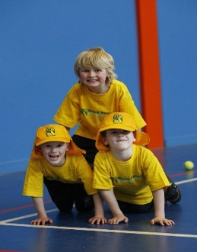
When: Fridays
Starts: 3nd May
Finishes: 21st June
Dance: 1:40pm – 2:30pm
Sports: 3:40pm – 4:40pm
Year Levels: Prep – 4
Cost: $105.60 per program(Inc GST)

