
GREENVALE
PRIMARY SCHOOL P (03) 9384 2204
M 0403 149 391

E mitch@kellysports.com.au
SIZZLING SUMMER SPORTS – After School
Kelly Sports is back in Term 1 for a SIZZLING SUMMER OF SPORTS!!
Our Kelly Sports classes are all inclusive, fun & interactive with a key focus on maximum participation. Each week children will be introduced to new sports & activities in a positive environment. It’s a fantastic way to get your child active while having fun as well as building confidence and social skills!
TENNIS – After School
BE THE NEXT TENNIS SENSATION! We are once again offering our Tennis program at lunch time. With many engaging activities in this program, your child will have plenty of time to work on all their Tennis Skills! This program includes a chance for your child to not only be energetic, but also build up their motor skills tailored to their age group.

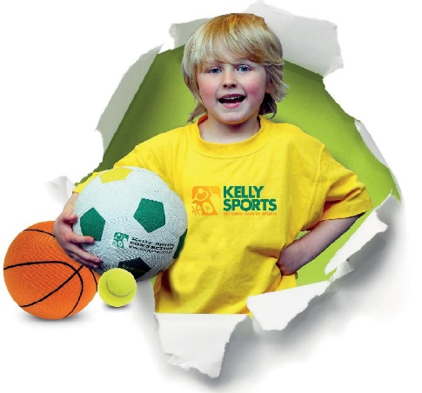

How To Enrol?
Please visit www.kellysports.com.au/events and search for your school.
Our new booking system requires upfront payments to secure your position. For more information, please call the head office.


"The Kelly Sports Programs offer our students opportunities for physical activities; including dance & multi-sports. Conveniently located on our school grounds, they are popular with students and their families. Staff are skilled in working with young people to love active participation.”


Amanda Hay, Principal – Newtown Primary School
CLASS INFORMATION
Only 14 spots available for each program so sign up fast to secure your position
Multi Sports includes Soccer, Basketball, Cricket & Dodgeball, plus we will incorporate our Kelly Sports Modified games children love.
Come & join us every Thursday straight after school.
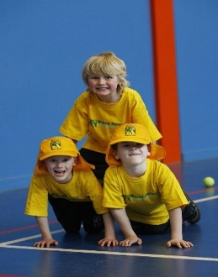
When: Thursday
Starts: 7TH Feb
Finishes: 4th April
Time: 3:40pm – 4:40pm
Year Levels: Prep – 4
Cost: $118.80 (Inc GST)

