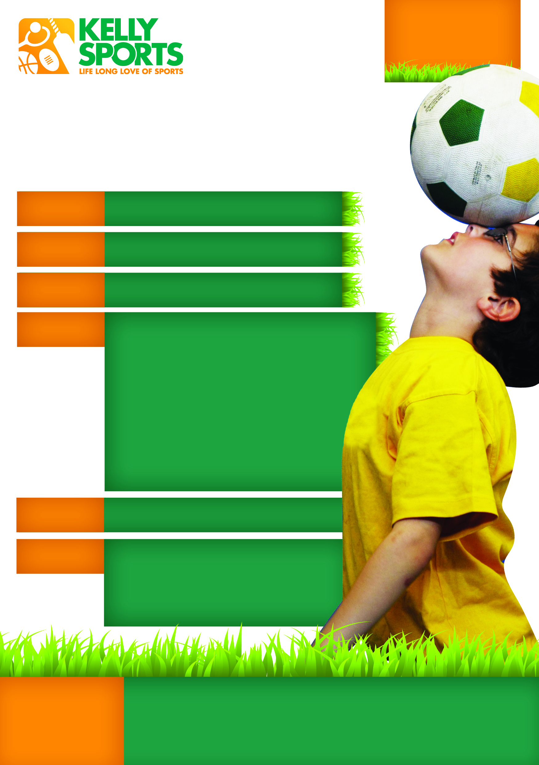

Competitions
Lots of Prizes!
AND SO MUCH MORE!
Water Games!
Bring a Friend
THESE HOLIDAYS WE HAVE…
Sport Quizzes
Giant Board Games
Tues 19th Jan – Thurs 21st Jan
8:00am – 5:00pm daily
Mitch Robertson
M 0417 102 933
T (03) 9384 2204
F (03) 9384 2205
E mitch@kellysports.com.au
Sports orientated holiday program designed for children
SUMMER HOLIDAY PROGRAM
Enjoy your school holidays this Summer with Kelly Sports. These programs are designed to help kids develop basic skills such as kicking, throwing and catching, all in a fun engaging and exciting environment. Sports included are Basketball, Netball, Cricket, Rippa Rugby, T-Ball, AFL, Soccer, Tennis, Dancing, Gymnastics and many more.
SCORCHING SUMMER SPORTS!
Ages 4-12
SUNBURY
$40 per day
SPECIAL DISCOUNT Full 3 days for $100
THREE WAYS TO ENROL
HOLIDAY

PROGRAM

to emphasise fun, enjoyment and maximum participation.

- Online: www.kellysports.com.au
- Call/email Mitch (contact details above)
- Return the form: PO Box 71, Moonee Vale, VIC 3055

WHERE
WHEN
WHO
INFO
COST
ENROL

- Friendly and experienced coaches teaching skills and providing an exciting and safe environment.
- Lots of variety to ensure your child will have loads of fun every day.
- Challenges and prizes that kids will love.

Our Lady of Mount Carmel PS
53 Macedon St, Sunbury VIC 3429

