
VALKSTONE PS
P (03) 9384 2204
M 0403 149 391
E mitch@kellysports.com.au


SPRING MULTI SPORTS

Come and experience all the fun in our 9 week Kelly Sports
Spring Multi Sport program.
Our Kelly Sports classes are all inclusive, fun & interactive with a key focus on maximum participation. Each week children will be introduced to new sports & activities in a positive environment. It’s a fantastic way to get your child active while having fun as well as building confidence and social skills!

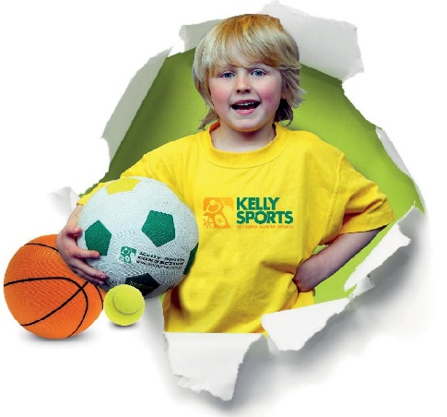


How To Enrol?
Please visit www.kellysports.com.au/events and search for your school.
Our new booking system requires upfront payments to secure your position. For more information, please call the head office.

"The Kelly Sports Programs offer our students opportunities for physical activities; including dance & multi-sports. Conveniently located on our school grounds, they are popular with students and their families. Staff are skilled in working with young people to love active participation.”


Amanda Hay, Principal – Newtown Primary School
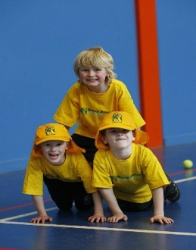
CLASS INFORMATION
Only 14 spots available so sign up fast to secure your position
Activities include Soccer, Hockey, Basketball, Cricket & Crazy games, plus we will incorporate our Kelly Sports Modified games children love

Come & join us every Wednesday straight after school.
When: Wednesdays
Starts: 17TH October
Finishes: 12th December
Time: 3:35pm – 4:35pm
Year Levels: Prep – 4
Cost: $118.80 (Inc GST)

