

P.O. Box 71, Moonee Vale 3055
Get this for $99.00 if you enrol before the 24th September!
T (03) 9384 2204
F (03) 9384 2205

E mitch@kellysports.com.au


GREENVALE PRIMARY SCHOOL
SPORTY SPRING PROGRAM
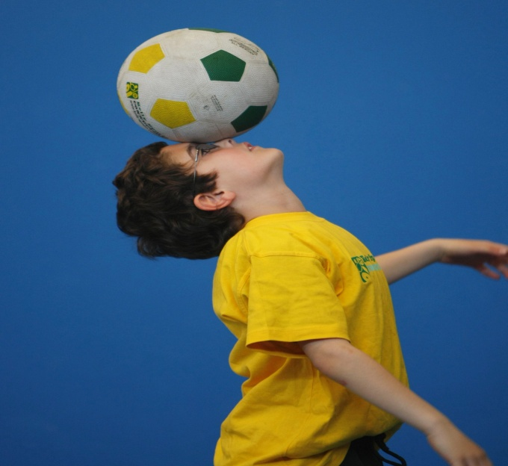
WHEN: Thursday
COMMENCING: 06/10/16
CONCLUDING: 01/12/16
TIME: 3.40pm – 4.40pm
YEAR LEVELS: P – 4
COST: $108

SOCCER – HOCKEY – BASKETBALL – CRICKET – CRAZY GAMES This program is a fantastic way to challenge and improve your child’s motor and coordination skills. Our experienced coaches aim to develop and enhance the wide range of sporting skills of your child, including catching, kicking, throwing and Striking. While also improving strength, flexibility, hand-eye co-ordination, spatial awareness, co-operative skills and teamwork, all within a FUN and very SAFE environment.



END OF YEAR CHEER

WHEN: Thursday
COMMENCING: 06/10/16
CONCLUDING: 01/12/16
TIME: 3.40pm – 4.40pm
YEAR LEVELS: P – 4
COST: $108

IT’S THE END OF THE YEAR AND IT’S TIME TO CHEER! Join us for our Cheerleading program for boys and girls as the kids learn weekly moves and learn a routine to perform at the end of the year.

GET IN QUICK FOR TERM 4 AS PLACES FILLING FAST
It’s here online enrolments !
To enrol, please visit www.kellysports.com.au or
fill out the enrolment form & send with a cheque or credit card details to:
Kelly Sports PO BOX 71, Moonee Vale, VIC, 3055.
Payment options available!
Do not leave enrolment forms at the school office


$120 FOR 10 WEEK PROGRAM
NEW IMPROVED ONLINE BOOKING SYSTEM!!!
SIMPLY GO TO WWW.KELLYSPORTS.COM.AU ENTER YOUR POST CODE AND ENROL FROM THERE. OR
FILL OUT THE BELOW ENROLMENT FORM & SEND WITH A CHEQUE OR CREDIT CARDS DETAILS TO:
PO BOX 71, MOONEE VALE, 3055
PAYMENT OPTIONS AVALIABLE!

It’s here online enrolments !
To enrol, please visit www.kellysports.com.au or
fill out the enrolment form & send with a cheque or credit card details to:
Kelly Sports PO BOX 71, Moonee Vale, VIC, 3055.
Payment options available!
Do not leave enrolment forms at the school office

ENROLMENT FORM
Sporty Spring Program End of Year Cheer
School: Year Level:
Name: Room No:
Address: Post Code:
Phone: Mobile/Work:
Email: Medical Conditions:

At the completion of after school clinics, does your child? Go to after care Get collected
Parents’ consent: I hereby authorise Kelly Sports to act on my behalf should my child require medical attention, and release
Kelly Sports from any liability for injury incurred by my child at Kelly Sports programs.
Parent/Caregiver name: Signature:
Amount Paid: $ Credit card payment: Visa Master card
Card Number: Expiry Date: /CVV:
THINGS TO KNOW
Kelly Sports is a Registered Child Care provider
Don’t leave forms at the School Office
Spaces are limited so please make sure you enrol online or return form to Kelly Sports.

It’s here online enrolments !
To enrol, please visit www.kellysports.com.au or
fill out the enrolment form & send with a cheque or credit card details to:
Kelly Sports PO BOX 71, Moonee Vale, VIC, 3055.
Payment options available!
Do not leave enrolment forms at the school office

It’s here online enrolments !
To enrol, please visit www.kellysports.com.au or
fill out the enrolment form & send with a cheque or credit card details to:
Kelly Sports PO BOX 71, Moonee Vale, VIC, 3055.
Payment options available!
Do not leave enrolment forms at the school office

It’s here online enrolments !
To enrol, please visit www.kellysports.com.au or
fill out the enrolment form & send with a cheque or credit card details to:
Kelly Sports PO BOX 71, Moonee Vale, VIC, 3055.
Payment options available!
Do not leave enrolment forms at the school office

