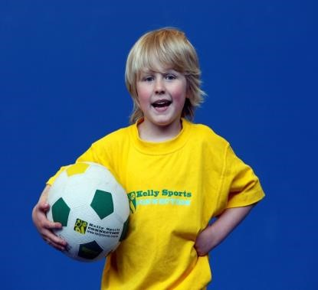

P.O. Box 71, Moonee Vale 3055

T
(03) 9384 2204

F
(03) 9384 2205

E

mitch
@kellysports.com.au

ST THOMAS THE APOSTLE P.S

WHEN:

Thursda
y

COMMENCING:

23
07
/
/15

CONCLUDING:

17
/
09
/15

TIME:

3.40
pm

–

pm
4.40

YEAR LEVELS:

P
–

6

COST:

$
90

Soccer
–

AF
L
–

Ultimate Frisbee
–

Striking Games

This program is a fantastic way to challenge and
improve your child’s motor and coordination
skills. Our experienced coaches aim to develop
and enhance the wide rang
e of sporting skills of
your child, including catching, kicking & throwing.
While also improving strength, flexibility, hand
-
eye co
-
ordination, spatial awareness, co
-
operative skills and teamwork all within a
FUN

and very
SAFE

environment.

WILD WINTER SPORTS

F
OLLOW US

ONLINE

GET IN QUICK FOR TERM 3 AS PLACES FILLING FAST $90 FOR 9 WEEK PROGRAM

NEW IMPROVED ONLINE BOOKING SYSTEM!!!
SIMPLY GO TO WWW.KELLYSPORTS.COM.AU ENTER YOUR POST CODE AND ENROL FROM THERE. OR

FILL OUT THE BELOW ENROLMENT FOR & SEND WITH A CHEQUE OR CREDIT CARDS DETAILS TO: PO BOX 71, MOONEE VALE, 3055 PAYMENT OPTIONS AVALIABLE!
 Wild Winter Sports
School: |  |  |  | Year Level:
Name: |  |  |  | Room No:
Address: |  |  |  | Post Code:
Phone: | Mobile/Work:
Email: | Medical Conditions:
ENROLMENT FORM
At the completion of after school clinics, does your child?  Go to after care  Get collected
Parents’ consent: I hereby authorise Kelly Sports to act on my behalf should my child require medical attention, and release Kelly Sports Blackburn from any liability for injury incurred by my child at Kelly Sports programs.
Amount Paid: $ | Credit card payment:  Visa  Master card
Parent/Caregiver name: Signature:
Card Number:    Expiry Date: /CVV:
THINGS TO KNOW
Kelly Sports is a Registered Child Care provider
Don’t leave forms at the School Office
Spaces are limited so please make sure you enrol online or return form to Kelly Sports.

