 P.O. Box 71, Moonee Vale 3055
T (03) 9384 2204
FOLLOW US
ONLINE

F (03) 9384 2205

E mitch@kellysports.com.au



HOLY FAMILY PRIMARY SCHOOL
SPRING INTO SPORTS
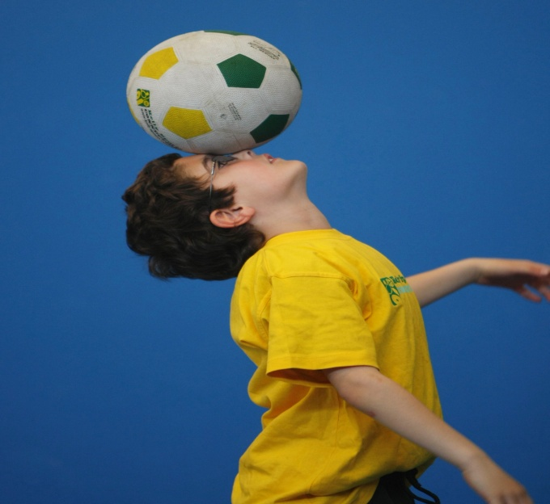
WHEN: Wednesday
COMMENCING: 14/10/15
CONCLUDING: 9/12/15
TIME: 3.20pm – 4.20pm
YEAR LEVELS: P – 4
COST: $100

Have fun in the sun this term! Super Spring Sports dynamic and active programs run over 10 weeks; these include: Soccer, Hockey, Basketball, Cricket and team games.
This Program will not only provide an essential base for your child's motor skills but help build awareness, co-ordination and friendship all in an enjoyable environment.


END OF YEAR CHEER


WHEN: Friday
COMMENCING: 16/10/15
CONCLUDING: 11/12/15
TIME: 1.40pm – 2.30pm
YEAR LEVELS: P – 4
COST: $100

IT’S THE END OF THE YEAR AND IT’S TIME TO CHEER! Join us for our Cheerleading program for boys and girls as the kids learn weekly moves and learn a routine to perform at the end of the year.
Book early for this incredibly fun program!

GET IN QUICK FOR TERM 4 AS PLACES FILLING FAST
It’s here online enrolments !
To enrol, please visit www.kellysports.com.au or
fill out the enrolment form & send with a cheque or credit card details to:
Kelly Sports PO BOX 71, Moonee Vale, VIC, 3055.
Payment options available!
Do not leave enrolment forms at the school office

$100 FOR 10 WEEK PROGRAM

NEW IMPROVED ONLINE BOOKING SYSTEM!!!
SIMPLY GO TO WWW.KELLYSPORTS.COM.AU ENTER YOUR POST CODE AND ENROL FROM THERE. OR
FILL OUT THE BELOW ENROLMENT FOR & SEND WITH A CHEQUE OR CREDIT CARDS DETAILS TO:
PO BOX 71, MOONEE VALE, 3055
PAYMENT OPTIONS AVALIABLE!

It’s here online enrolments !
To enrol, please visit www.kellysports.com.au or
fill out the enrolment form & send with a cheque or credit card details to:
Kelly Sports PO BOX 71, Moonee Vale, VIC, 3055.
Payment options available!
Do not leave enrolment forms at the school office

ENROLMENT FORM
Spring into Sports End of year cheer
School: Year Level:
Name: Room No:
Address: Post Code:
Phone: Mobile/Work:
Email: Medical Conditions:

At the completion of after school clinics, does your child? Go to after care Get collected
Parents’ consent: I hereby authorise Kelly Sports to act on my behalf should my child require medical attention, and release
Kelly Sports Knox-Waverley from any liability for injury incurred by my child at Kelly Sports programs.
Parent/Caregiver name: Signature:
Amount Paid: $ Credit card payment: Visa Master card
Card Number: Expiry Date: /CVV:
THINGS TO KNOW
Kelly Sports is a Registered Child Care provider
Don’t leave forms at the School Office
Spaces are limited so please make sure you enrol online or return form to Kelly Sports.

It’s here online enrolments !
To enrol, please visit www.kellysports.com.au or
fill out the enrolment form & send with a cheque or credit card details to:
Kelly Sports PO BOX 71, Moonee Vale, VIC, 3055.
Payment options available!
Do not leave enrolment forms at the school office

It’s here online enrolments !
To enrol, please visit www.kellysports.com.au or
fill out the enrolment form & send with a cheque or credit card details to:
Kelly Sports PO BOX 71, Moonee Vale, VIC, 3055.
Payment options available!
Do not leave enrolment forms at the school office

It’s here online enrolments !
To enrol, please visit www.kellysports.com.au or
fill out the enrolment form & send with a cheque or credit card details to:
Kelly Sports PO BOX 71, Moonee Vale, VIC, 3055.
Payment options available!
Do not leave enrolment forms at the school office

