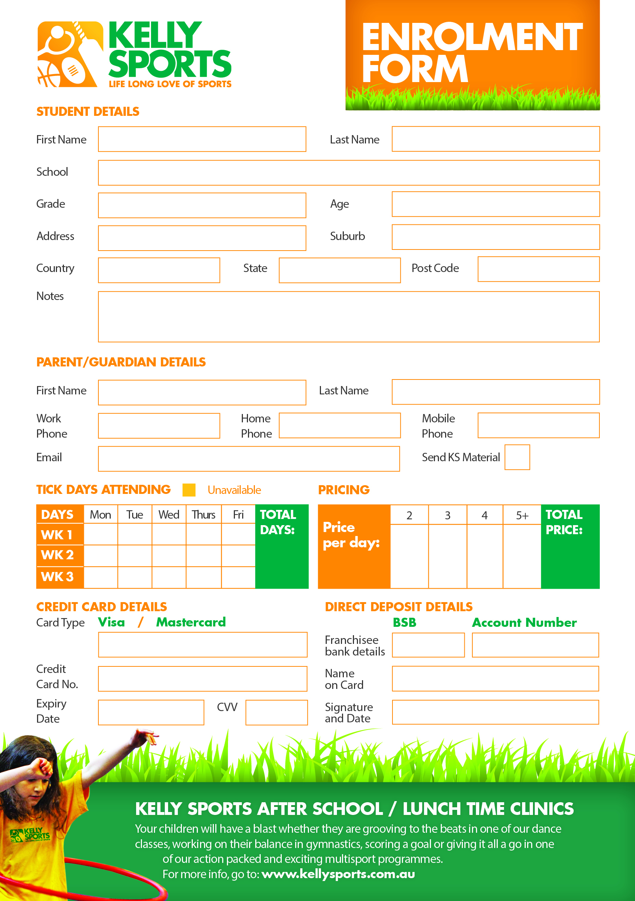
633000
122016876

$30
per
day

$35

$140

$105

$70

$

