

P.O. Box 71, Moonee Vale 3055
SPECIAL OFFER! Total Program cost $110 sign up before 27th June
T (03) 9384 2204
F (03) 9384 2205

E mitch@kellysports.com.au


GREENVALE PRIMARY SCHOOL
WACKY WINTER SPORTS
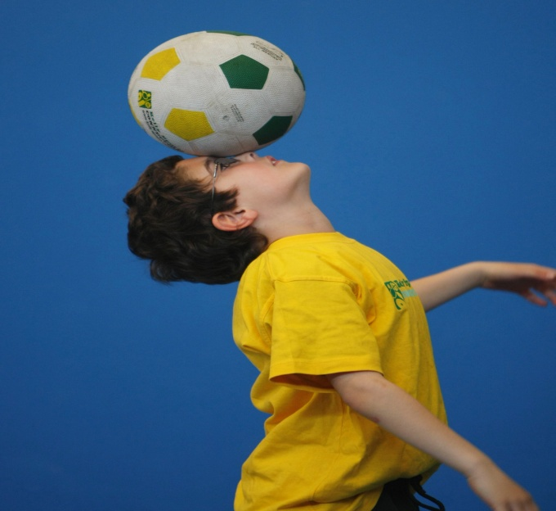
WHEN: Thursday
COMMENCING: 21/07/15
CONCLUDING: 15/09/15
TIME: 3.40pm – 4.40pm
YEAR LEVELS: P – 4
COST: $120

SOCCER – BASKETBALL- AFL – TEEBALL – TEAM GAMES This program is a fantastic way to challenge and improve your child’s motor and coordination skills. Our experienced coaches aim to develop and enhance the wide range of sporting skills of your child, including catching, kicking & throwing. While also improving strength, flexibility, hand-eye co-ordination, spatial awareness, co-operative skills and teamwork, all within a FUN and very SAFE environment.



WHEN: Thursday
COMMENCING: 21/07/15
CONCLUDING: 15/09/15
TIME: 3.40pm – 4.40pm
YEAR LEVELS: P – 4
COST: $120

GYMNASTICS

BEND YOUR WAY TO GYM CLUB THIS TERM! This fast paced, highly active and nonstop program is an introduction for your child to the world of gymnastic. Colorful Ribbons, Entertaining Hula Hoops, Fantastic Rhythmical Routines and Group Dynamics allow your child to build up their thirst for energetic activities

GET IN QUICK FOR TERM 3 AS PLACES FILLING FAST
It’s here online enrolments !
To enrol, please visit www.kellysports.com.au or
fill out the enrolment form & send with a cheque or credit card details to:
Kelly Sports PO BOX 71, Moonee Vale, VIC, 3055.
Payment options available!
Do not leave enrolment forms at the school office


$120 FOR 10 WEEK PROGRAM
NEW IMPROVED ONLINE BOOKING SYSTEM!!!
SIMPLY GO TO WWW.KELLYSPORTS.COM.AU ENTER YOUR POST CODE AND ENROL FROM THERE. OR
FILL OUT THE BELOW ENROLMENT FORM & SEND WITH A CHEQUE OR CREDIT CARDS DETAILS TO:
PO BOX 71, MOONEE VALE, 3055
PAYMENT OPTIONS AVALIABLE!

It’s here online enrolments !
To enrol, please visit www.kellysports.com.au or
fill out the enrolment form & send with a cheque or credit card details to:
Kelly Sports PO BOX 71, Moonee Vale, VIC, 3055.
Payment options available!
Do not leave enrolment forms at the school office

ENROLMENT FORM
Wacky Winter Sports Gymnastics
School: Year Level:
Name: Room No:
Address: Post Code:
Phone: Mobile/Work:
Email: Medical Conditions:

At the completion of after school clinics, does your child? Go to after care Get collected
Parents’ consent: I hereby authorise Kelly Sports to act on my behalf should my child require medical attention, and release
Kelly Sports from any liability for injury incurred by my child at Kelly Sports programs.
Parent/Caregiver name: Signature:
Amount Paid: $ Credit card payment: Visa Master card
Card Number: Expiry Date: /CVV:
THINGS TO KNOW
Kelly Sports is a Registered Child Care provider
Don’t leave forms at the School Office
Spaces are limited so please make sure you enrol online or return form to Kelly Sports.

It’s here online enrolments !
To enrol, please visit www.kellysports.com.au or
fill out the enrolment form & send with a cheque or credit card details to:
Kelly Sports PO BOX 71, Moonee Vale, VIC, 3055.
Payment options available!
Do not leave enrolment forms at the school office

It’s here online enrolments !
To enrol, please visit www.kellysports.com.au or
fill out the enrolment form & send with a cheque or credit card details to:
Kelly Sports PO BOX 71, Moonee Vale, VIC, 3055.
Payment options available!
Do not leave enrolment forms at the school office

It’s here online enrolments !
To enrol, please visit www.kellysports.com.au or
fill out the enrolment form & send with a cheque or credit card details to:
Kelly Sports PO BOX 71, Moonee Vale, VIC, 3055.
Payment options available!
Do not leave enrolment forms at the school office

