

P.O. Box 71, Moonee Vale 3055
SPECIAL OFFER! Total program cost $88 Sign up before 27th June
T (03) 9384 2204
F (03) 9384 2205

E mitch@kellysports.com.au


GOOD SAMARITAN PRIMARY SCHOOL
WACKY WINTER SPORTS
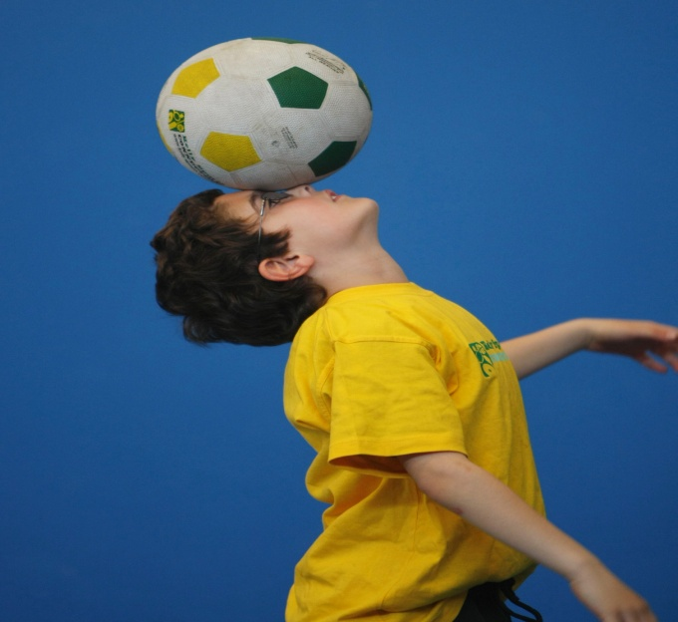
WHEN: Friday
COMMENCING: 22/07/15
CONCLUDING: 09/09/15
TIME: 3.40pm – 4.40pm
YEAR LEVELS: P – 4
COST: $96

SOCCER – BASKETBALL- AFL – TEEBALL – TEAM GAMES This program is a fantastic way to challenge and improve your child’s motor and coordination skills. Our experienced coaches aim to develop and enhance the wide range of sporting skills of your child, including catching, kicking & throwing. While also improving strength, flexibility, hand-eye co-ordination, spatial awareness, co-operative skills and teamwork, all within a FUN and very SAFE environment.



WHEN: Thursday
COMMENCING: 14/07/15
CONCLUDING: 15/09/15
TIME: 1.30pm – 2.10pm
YEAR LEVELS: P – 4
COST: $96

KELLY SPORTS OLYMPICS

KELLY SPORTS OLYMPICS is a dynamic and active program run the course of the term. Our experienced coaches will teach your child all the fundamental skills needed to become the next Olympic Gold medalist. The program will include Olympic events such as Soccer, Tennis, Rugby 7’s, Gymnastics, Athletics and much more.

GET IN QUICK FOR TERM 3 AS PLACES FILLING FAST
It’s here online enrolments !
To enrol, please visit www.kellysports.com.au or
fill out the enrolment form & send with a cheque or credit card details to:
Kelly Sports PO BOX 71, Moonee Vale, VIC, 3055.
Payment options available!
Do not leave enrolment forms at the school office


$96 FOR 8 WEEK PROGRAM
NEW IMPROVED ONLINE BOOKING SYSTEM!!!
SIMPLY GO TO WWW.KELLYSPORTS.COM.AU ENTER YOUR POST CODE AND ENROL FROM THERE. OR
FILL OUT THE BELOW ENROLMENT FOR & SEND WITH A CHEQUE OR CREDIT CARDS DETAILS TO:
PO BOX 71, MOONEE VALE, 3055
PAYMENT OPTIONS AVALIABLE!

It’s here online enrolments !
To enrol, please visit www.kellysports.com.au or
fill out the enrolment form & send with a cheque or credit card details to:
Kelly Sports PO BOX 71, Moonee Vale, VIC, 3055.
Payment options available!
Do not leave enrolment forms at the school office

ENROLMENT FORM
Wacky Winter Sports Kelly Sports Olympics
School: Year Level:
Name: Room No:
Address: Post Code:
Phone: Mobile/Work:
Email: Medical Conditions:

At the completion of after school clinics, does your child? Go to after care Get collected
Parents’ consent: I hereby authorise Kelly Sports to act on my behalf should my child require medical attention, and release
Kelly Sports Nth West from any liability for injury incurred by my child at Kelly Sports programs.
Parent/Caregiver name: Signature:
Amount Paid: $ Credit card payment: Visa Master card
Card Number: Expiry Date: /CVV:
THINGS TO KNOW
Kelly Sports is a Registered Child Care provider
Don’t leave forms at the School Office
Spaces are limited so please make sure you enrol online or return form to Kelly Sports.

It’s here online enrolments !
To enrol, please visit www.kellysports.com.au or
fill out the enrolment form & send with a cheque or credit card details to:
Kelly Sports PO BOX 71, Moonee Vale, VIC, 3055.
Payment options available!
Do not leave enrolment forms at the school office

It’s here online enrolments !
To enrol, please visit www.kellysports.com.au or
fill out the enrolment form & send with a cheque or credit card details to:
Kelly Sports PO BOX 71, Moonee Vale, VIC, 3055.
Payment options available!
Do not leave enrolment forms at the school office

It’s here online enrolments !
To enrol, please visit www.kellysports.com.au or
fill out the enrolment form & send with a cheque or credit card details to:
Kelly Sports PO BOX 71, Moonee Vale, VIC, 3055.
Payment options available!
Do not leave enrolment forms at the school office

