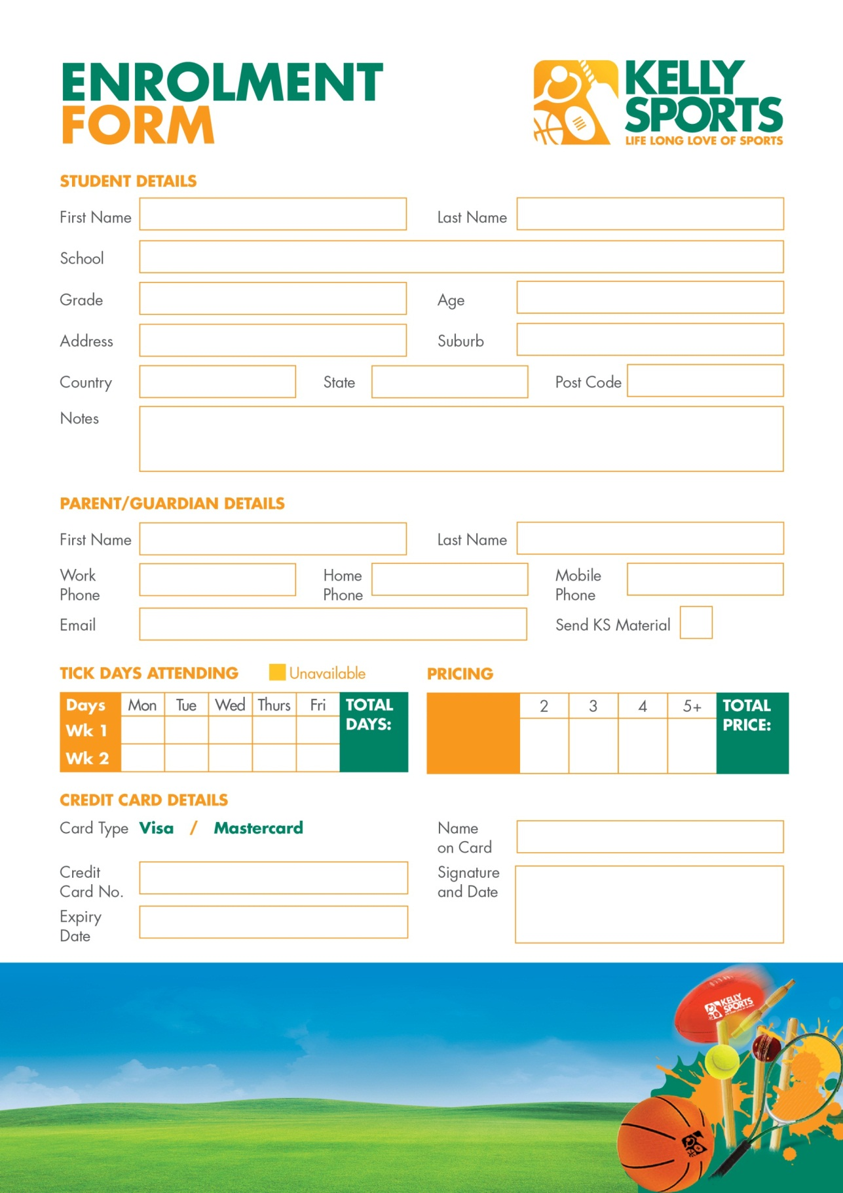
$150
$140
$105
$70
$35
Price per day:

For more info, go to
www.kellysports.com.au

Your children will have a blast whether they are grooving to the beats in one of our dance classes, working on their balance in gymnastics, hitting a six in cricket or giving it all a go in one of our action packed and exciting multisport programmes.

KELLY SPORTS AFTER SCHOOL / LUNCH TIME CLINICS

