

PO BOX 28 Cranbourne 3977
FOLLOW US FACEBOOK.

T 0430 580 788

E david@kellysports.com.au

Phone 0430 580 788


ST AGATHAS PRIMARY SCHOOL
WILD AUTUMN SPORTS
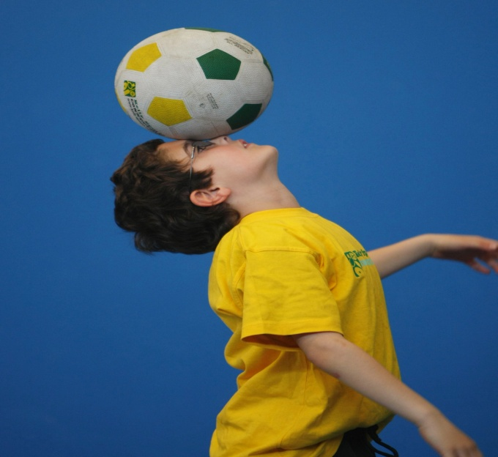
SOCCER – BASKETBALL- AFL, HOCKEY – CRAZY GAMES This program is a fantastic way to challenge and improve your child’s motor and coordination skills. Our experienced coaches aim to develop and enhance the wide range of sporting skills of your child, including catching, kicking & throwing. While also improving strength, flexibility, hand-eye co-ordination, spatial awareness, co-operative skills and teamwork, all within a FUN and very SAFE environment.
WHEN: MONDAY
COMMENCING: 29/4/19
CONCLUDING: 24/6/19
TIME: 3.40pm – 4.40pm
YEAR LEVELS: P – 4
COST: $96.00 (Including GST)


JAZZ FUNK DANCE


Breaking, Popping and Locking!! Our specialized Dance coaches can get your child’s hips swinging, feet rocking and heads bumping to the original Jazz Funk dancing.. Jazz Funk is a FUSION of styles that you child can enjoy dancing out to!!!! Sign up fast as places are limited for our program and let our coaches beat, ignite your child’s feet.
WHEN: Tuesday
COMMENCING: 30/4/19
CONCLUDING: 25/6/19
TIME: 1.15pm-2.00pm
YEAR LEVELS: P – 4
COST: $108.00 (Including GST)

GET IN QUICK FOR TERM 1 AS PLACES FILLING FAST
It’s here online enrolments !
To enrol, please visit www.kellysports.com.au or
fill out the enrolment form & send with a cheque or credit card details to:
Kelly Sports PO BOX 71, Moonee Vale, VIC, 3055.
Payment options available!
Do not leave enrolment forms at the school office


SIGN UP FAST TO HAVE FUN WHILE LEARNING NEW SKILLS!
SIMPLY GO TO WWW.KELLYSPORTS.COM.AU ENTER YOUR POST CODE AND ENROL FROM THERE. OR
FILL OUT THE BELOW ENROLMENT FORM & SEND WITH A CHEQUE OR CREDIT CARDS DETAILS TO:
P.O BOX 28 CRANBOURNE 3977
PAYMENT OPTIONS AVAILABLE!

It’s here online enrolments !
To enrol, please visit www.kellysports.com.au or
fill out the enrolment form & send with a cheque or credit card details to:
Kelly Sports PO BOX 71, Moonee Vale, VIC, 3055.
Payment options available!
Do not leave enrolment forms at the school office

ENROLMENT FORM
Wild Autumn Sports Jazz Funk Dance
School: Year Level:
Name: Room No:
Address: Post Code:
Phone: Mobile/Work:
Email: Medical Conditions:

At the completion of after school clinics, does your child? Go to after care Get collected
Parents’ consent: I hereby authorise Kelly Sports to act on my behalf should my child require medical attention, and release
Kelly Sports Western Region from any liability for injury incurred by my child at Kelly Sports programs.
Parent/Caregiver name: Signature:
Amount Paid: $ Credit card payment: Visa Master card
Card Number: Expiry Date: /CVV:
THINGS TO KNOW

Don’t leave forms at the School Office
Spaces are limited so please make sure you enrol online or return form to Kelly Sports.

It’s here online enrolments !
To enrol, please visit www.kellysports.com.au or
fill out the enrolment form & send with a cheque or credit card details to:
Kelly Sports PO BOX 71, Moonee Vale, VIC, 3055.
Payment options available!
Do not leave enrolment forms at the school office

It’s here online enrolments !
To enrol, please visit www.kellysports.com.au or
fill out the enrolment form & send with a cheque or credit card details to:
Kelly Sports PO BOX 71, Moonee Vale, VIC, 3055.
Payment options available!
Do not leave enrolment forms at the school office

It’s here online enrolments !
To enrol, please visit www.kellysports.com.au or
fill out the enrolment form & send with a cheque or credit card details to:
Kelly Sports PO BOX 71, Moonee Vale, VIC, 3055.
Payment options available!
Do not leave enrolment forms at the school office

