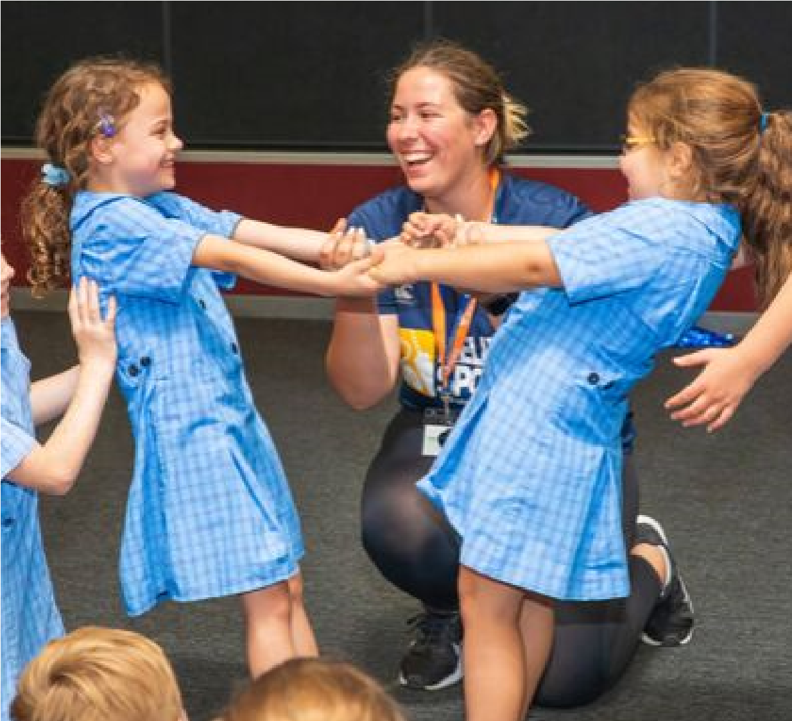
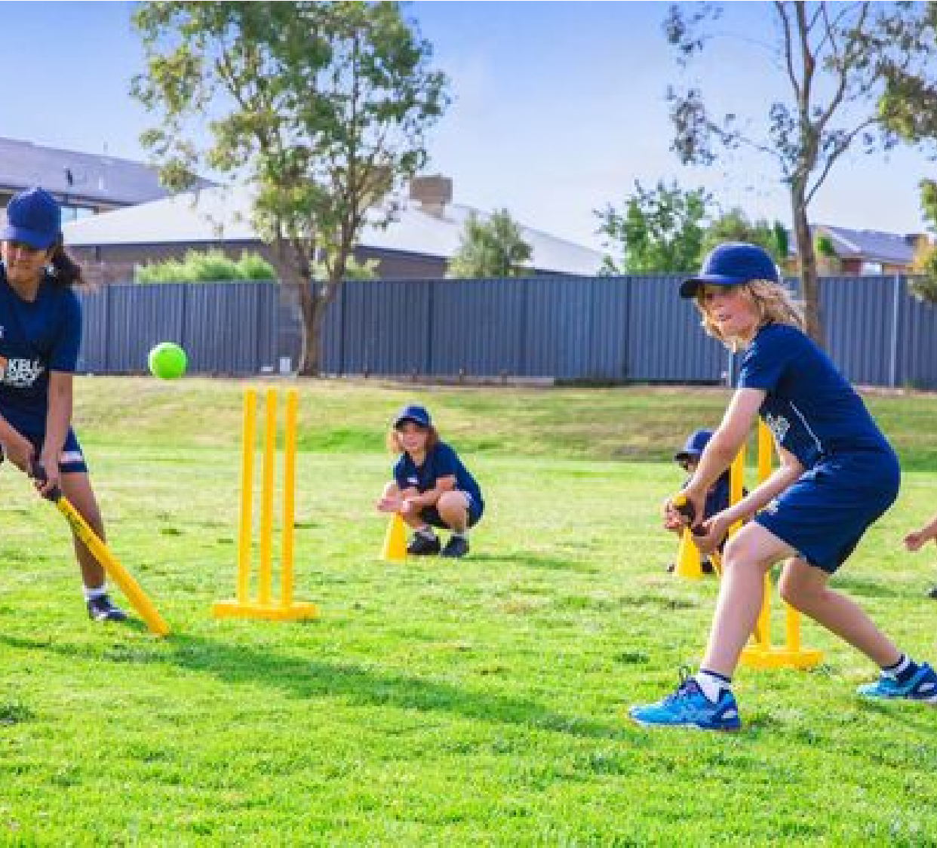


DANCE
PROGRAMME
TERM 4 2019
Have heaps of fun in the sun with your friends
while playing a range of dynamic and active
sports over the term.
It's the end of the year and it's time to cheer!
Combining Hip Hop and Cheerleading to
create a new and fresh routine in our high
intensity, excitement-filled programme.
MULTI-SPORTS
PROGRAMME
TERM 4 2019


MULTI-SPORTS
PROGRAMME
TERM 4 2019 INFORMATION
PRICES FROM $108.00 TO $120.00
St Agathas P.S – Mon, 3.40 -4.40pm. $108.00
Lyndhurst P.S – Tues, 3.40 - 4.40pm $108.00
St Joachims P.S – Tues, 3.25- 4.25pm $108.00
Rangebank P.S – Wed, 3.40- 4.40pm $120.00

For Prep – Year 4 students.
This term we will focus on the following sports:
Cricket
Programmes run weekly on one day a week for one hour.
Basketball
Soccer
Hockey

T- Ball
Crazy Games
This weekly programme gives children skills and confidence in a fun
and enjoyable environment. It also encourages their enthusiasm for
sport and the life skills that such involvement brings – giving them
confidence to join sports clubs and teams in the future.
BOOK EARLY & SAVE
Book before the 11th Oct to recieve $12.00 Discount.
David Marchesani
0430 580 788
david@kellysports.com.au
kellysports.com.au.
#KellySports Seaford
DANCE
PROGRAMME
TERM 4 2019 INFORMATION
PRICES FROM $99.00 TO $110.00
Rangebank P.S – Mon, 1.30 - 2.15pm $99.00
St Agathas P.S – Tues, 1.15-2.00pm $99.00
Lyndhurst P.S – Weds, 12.50-1.40pm $110.00
St Joachims P.S – Frid, 1.40-2.10pm $99.00

For Prep – Year 4 students.
This term we will focus on the following skills:
Hip Hop Dance
Programmes run weekly on one day a week for one hour.
Co-ordination
Dance Skills
This weekly programme gives children skills and confidence in a fun
and enjoyable environment. It also encourages their enthusiasm and
participation and the life skills that such involvement brings – giving
them increased confidence in the future.
BOOK EARLY & SAVE
Book before the 11th Oct to recieve $11.00

Discount.

