
RUSKIN PARK
PRIMARY SCHOOL P (03) 9384 2204
M 0403 149 391

E mitch@kellysports.com.au
WILD WINTER SPORTS
Have a sensational time with Kelly Sports in term 3. Kelly Sports dynamic and active programs run weekly throughout the term. Your child will love the variety of sports and activities, with a new sport every 2 weeks. This program will not only provide an essential base for your child's motor skills but help build awareness, co-ordination and friendship all in an enjoyable environment.

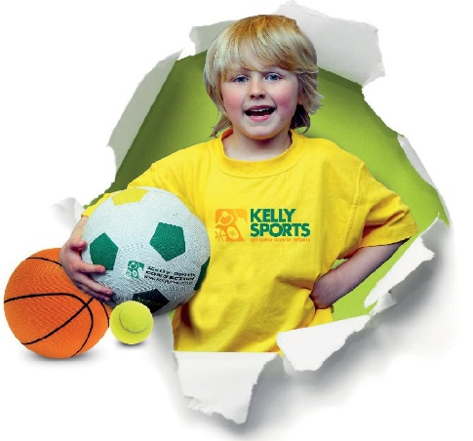


ONLINE ENROLMENT www.kellysports.com.au

To enrol, please visit www.kellysports.com.au, and search for your
school. Our booking system requires credit card upfront payments to
secure your position. For more information, please call the head office.


CLASS INFORMATION
Only 14 spots available for each program so sign up fast to secure your position
Multi Sports include Soccer, Basketball, AFL, European Handball & Athletics, plus we will incorporate our Kelly Sports Modified games children love.
Sign up anytime and only pay for the remaining weeks in the term - $13.20 per week
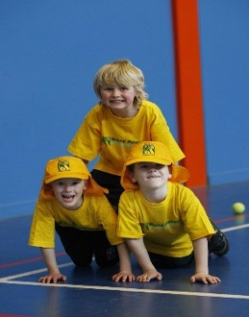
When: Thursday
Starts: 25th July
Finishes: 19th September
Time: 1:40pm – 2:25pm
Year Levels: Prep – 4
Cost: $118.80 Inc GST

"The Kelly Sports Programs offer our students opportunities for physical activities; including dance & multi-sports. Conveniently located on our school grounds, they are popular with students and their families. Staff are skilled in working with young people to love active participation.”

Amanda Hay, Principal – Newtown Primary School
