
SHEPPARTON SPORTS STADIUM HOLIDAY PROGRAM
Special offer: 5+ days for only $40 per day

Where: Shepparton Sports Stadium, Numurkah Rd, Shepparton, 3630
Cost: Only $45 per day
Enrol: samarchard@kellysports.com.au 0413919235 ⋅ www.kellysports.com.au


DAILY RUNDOWN
INTRODUCTION AND FUN GAMES INCLUDED EVERYDAY

– IN

 | MON | TUES | WED | THURS |  | FRI
 |  |  | WEEK 1
 | BASKETBALL  GYMNASTICS  FRISBEE  SOCCER   | AFL  HOCKEY  TBALL  KIDS CHOICE  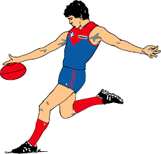 | CRICKET  DANCE  NETBALL  ATHLETICS   | HOCKEY  BASKETBALL  TEAM CHALLENGE   |  | SOCCER SKILLS    WORD CUP TOURNAMENT
 |  | WEEK 2
 | BASKETBALL  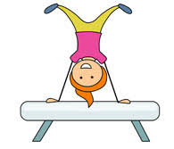  GYMNASTICS  CRICKET  SOCCER | AFL  HOCKEY  TENNIS   | CRICKET  CIRCUS  NETBALL  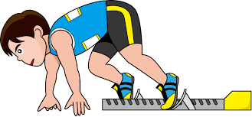  OLYMPIC EVENTS |  | HOCKEY  BASKETBALL  GOLF   | SOCCER  DANCE  KIDS CHOICE  

